SYLLABUS
OFFICE SECRETARYSHIP
Learning Outcomes:
By the successful completion of course,the student will be able to;
1. Understand the organizational hierarchy and outlines of functioning
2. Comprehend the role of office secretaryship in a small and medium organization
3. Acquire knowledge on office procedures and interpersonal skills
4. Apply the skills in preparing and presenting notes, letters, statements,reports in different situations. Syllabus
UNIT I: 06 hrs
Introduction – Organisational structure of a small and medium organization – Types of offices - Kinds of secretaries - The scope of office secretaryship
UNIT II: 10 hrs
The role of an office secretary -Duties and responsibilities- Usage of different devices - Flowchart and office manuals – Coordinating different wings of an office/organisaton – Arranging common meetings - Operations of banking and financial services - travel and hospitality management services
UNIT III: 10hrs
Office procedures – Filing– Circulating files - Preparation of notes, circulars, agenda and minutes of meetings – Issue of press notes - Maintenance of files and records - Inventory, office, human resources, financial and confidential - maintaining public relations. Co curricular Activities: 04 hrs 1. Visit various organizations (Hospitals, Hotels, Hospitality centers) 2. Preparation of appointment letters, dismissal letters, memos, Issue of appreciation/ motivation letters, 3. Releasing of Press notes, notices and circulars 4. Arranging invited lectures from office executives,auditors and managers 5. Assignments, Group discussion, Quiz etc.

OFFICE SECRETARYSHIP
UNIT I
Introduction – Organisational structure of a small and medium organization – Types of offices - Kinds of secretaries - The scope of office secretaryship
INTRODUCTION:
The word secretary is derived from the Latin word “Secretarius” which means “a confidential person”. A Secretary or Personal Assistant is the backbone of an organisation, whose work requires a variety of project management, communication and organizational skills.
Meaning of Office:
A building or room where clerical or professional duties are performed.
Meaning of secretary:
A person who is employed to take care of records, letters and routine work for another person.
Definition of Secretary Ship:
An Office Secretary maintains the smooth running of an office through a variety of administrative and clerical duties. They handle office schedules, coordinate meetings and visits, organize files, answer phones and perform a huge array of other essential tasks.
PERSONAL QUALITIES OF A SECRETARY
A secretary should possess a variety of soft skills to be successful and develop calm, positive personality. Some of the important personal qualities relevant for the job a private secretary are discussed below:
• Adaptability:
If Private Secretary has got the quality of adaptability, adjustment under all the situations in office becomes easy and less straining. It is important that a private secretary should be adaptable to all kinds of people, situations and problems. A secretary should inculcate the habit of adjusting with different types of persons/situations.
• Cooperative Attitude
In an organization, cooperativeness means assisting every member with a courteous and helpful attitude including exercising self-control at times of extra pressure. It is teamwork that counts in an organization.

• Courtesy
A secretary should show proper consideration for all members of the organization as well as to outside callers. One must avoid embarrassing anyone and making sarcastic comments. Courtesy may be shown in greeting each member and visitor pleasantly, offering a seat, etc.
• Loyalty
To be loyal means that faithful to the employer and always helpful to him/her. A secretary should be dedicated to the job and do assigned work honestly and sincerely.
• Punctuality
Punctuality means available to the executive for work at the desired time and also to finish the assigned job at the proper time. This simple but significant quality is very essential for a secretary. One must not be a „Late Starter‟ or „Early Stopper
• Tactfulness
Tact enables one to act in a particular fashion under particular situations. It is the personal skill in saying or doing what is required by the circumstances, the ability to handle a difficult situation in a right and positive manner. It has been truly called the “Fine art of avoiding offence”.
• Pleasing Voice
A secretary should have a low but confident well-controlled and pleasing voice. A pleasant, clear voice is attractive and loud while demanding voice is unattractive. It has also to be understood that a very low and retiring voice makes communication difficult.
• Personality and Poise
Personality is usually linked to what you are, what you do and how you do it. Personality makes one person different from another. It is not important what kind of features you have, but rather the expression on those features. Good personality creates a positive impact on other people
• Good Interpersonal Skills
Interpersonal skills are the skills which help a person to interact with others properly. In an organizational setting, it is the ability to get along well with other members; whether senior or junior.

ORGANISATIONAL STRUCTURE OF SMALL AND MEDIUM
Small and mid-size business (SMB) is a business that, due to its size, has different IT requirements—and often faces different IT challenges—than do large enterprises, and whose IT resources (usually budget and staff) are often highly constrained. For the purposes of its research, Gartner defines SMBs by the number of employees and annual revenue they have. The attribute used most often is number of employees; small businesses are usually defined as organizations with fewer than 100 employees; mid-size enterprises are those organizations with 100 to 999 employees.

Line organisation structure:
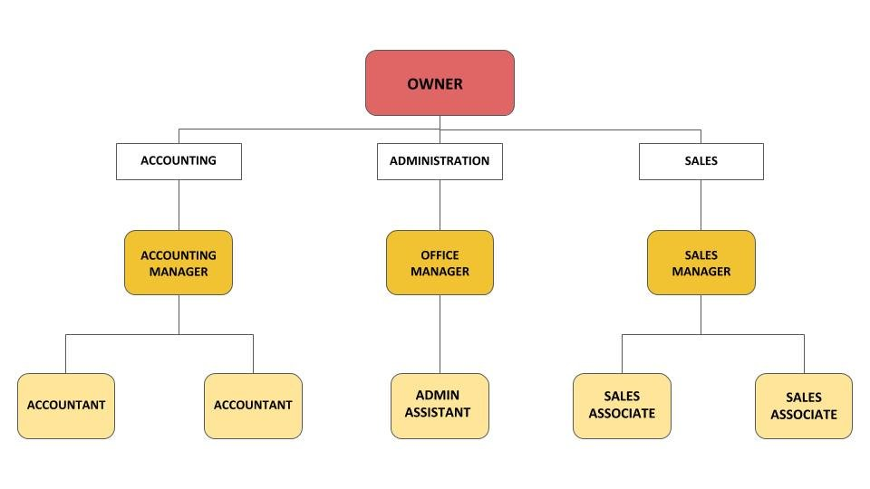
This structure is also known as the hierarchical organisational chart or a top-down organisational chart. It's one of the most popular structurebecause of its simplicity. The top of the chart shows the executives, then directors (for larger businesses) and department heads, and finally the employees each department head is responsible for. The hierarchy is simple and rigid. Information flows through each layer of the company in turn, and the structure disallows collaboration between teams.
Functional organisation structure:
This is identical to line organisational structure but offers more lines of communication. It lets directors and managers work together over teams they do not directly control, for better information flow and flexibility. In an SME, you're likely to have different teams with a lot of interaction; the sales department may have daily interaction with administration and with shipping. This structure establishes a hierarchy in every department while allowing for cross-communication.

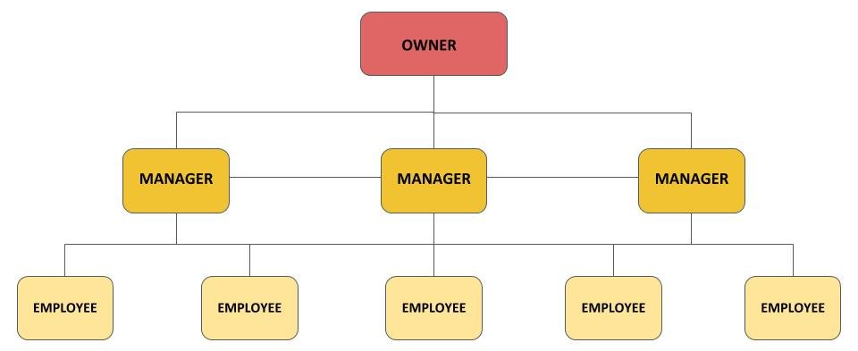
Line and staff organisation structure:
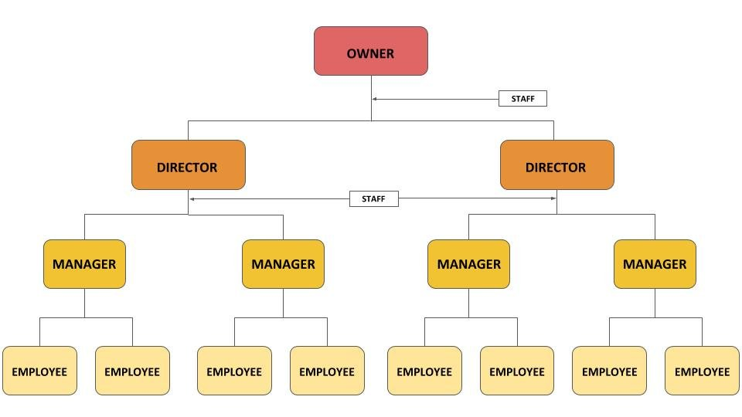
This structure is perfect for companies working in specialist fields. The staff in this situation refers to experts advisors providing:
- Technical information, opinions, and advice,
- Who may be allowed to authorise activities; and
- Help with reports that have weight in decision-making.
Staff and line positions have different objectives and are often ad odds. Conflicting expectations can be confusing for bottom-tier employees and result in lower productivity.
Project-based structure:

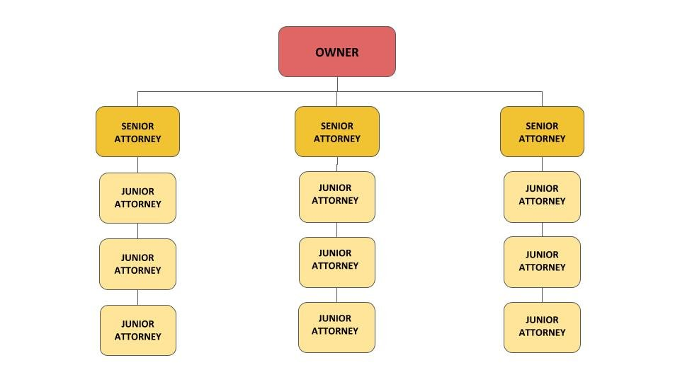
If your company operates with projects that are different from one client to the other and from one brief to the next, this is the best structure for you. The chart changes as needed for each project. Though it's helpful to be able to mix and match employees based on project needs, it does mean teams will need to adapt to new managers and colleagues for every assignment. Managers will need to be able to handle several functions across multiple departments. The director is at the top, appointing project manager for each project.
Matrix structure:
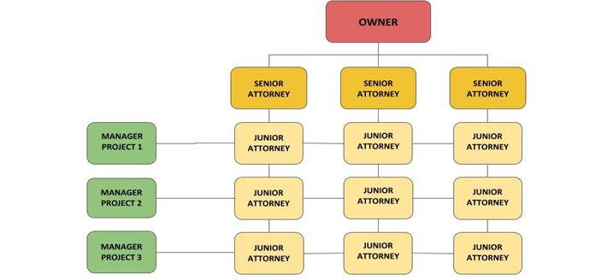
The matrix structure combines several types of organisational structures to create a customised solution to meet particular needs. It is characterised by more than one chain of command, with project team members reporting to two or more managers. This is perfect for businesses that are project-based, where teams must also follow a functional structure. Team leaders are assigned a representative from every functional area that applies to the project.
Circular structure:
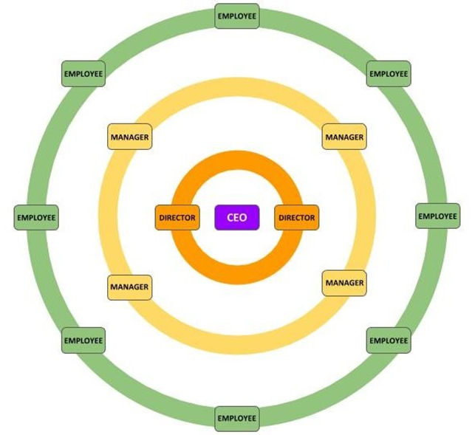
A circular structure still relies on hierarchy. Higher-level staff occupies the inner rings of the circle and lower-level workers occupy the outer rings. The executives aren't at the top, but on the inside to allow ideas to spread outward. The structure aims to promote open communication and the free flow of information between all parts of the organisation.
SCOPEOFOFFICESECRETARYSHIP:
In simple words, office secretary ship can be defined as “a distinct process of planning, organizing, staffing, directing, coordinating and controlling office in order to facilitate achievement of objectives of any business enterprise. The definition shows managerial functions of an administrative manager.
The following point enlightens the importance of office management:
- Helps in Achievement of Targets:
Targets or goals are results in quantitative terms which are to be achieved in a given time. Management makes people realize the goals and directs their efforts towards the achievement of these goals.
(ii) Optimum Use of Resources:
Management helps in utilization of resources effectively. Scarce resources are put to use optimistically by managers. Managers bring about coordination and integration of various resources. It is management which guides the personnel in office in the use of resources.
(iii) Minimization of Costs:
Office costs can only be reduced under the guidance and control of office management and SECRETARYSHIPOffice Management is concerned with doing the office activities in a best and cheapest way
(iv) SmoothFlowofWork:
Uninterruptedflowofworkisonlypossibleifthereisproperplanningand control.Managementensuresefficientandsmoothflowofwork.
(v) Helpsinsurvivalofmanagementefficiency:
Managementhelpsinmaintainingefficiencyinanoffice.Amanagernot onlyperformsandproducesresults,butalsodoesitinthemostefficient mannersoastocontributetowardsprofitgeneration.
(vi) ManagingSurvivalandGrowth:
Managementhastoplayanimportantroleinkeepingtheorganizationalive. Changeintechnologyandmethodsmustbeanticipatedandadaptedfor survivalandgrowth.

(vii) ProvidesInnovation:
Innovationisfindingnew, differentandbettermethodofdoingexisting work.Toplanandmanageinnovation, management hastoplayan importantrole.Suggestionsfromcustomers,informationfromsalesmenand closewatchoncompetitor’sactivitiesprovidesource of innovation.
(viii) HelpsinRetainingTalentandinculcating SenseofLoyaltyinOfficeStaff:
Efficientmanagementhelpsinretainingtalentedandhardworking employeesbyprovidingthemcomfortableworkenvironment.Manager mustmotivatehisemployeesbyrecognizingandappreciatingtheirtalents.

(ix) ProvidesLeadership:
Managementprovidesleadershipbyinfluencingandguidingoffice personnel.Managersinfluencehissubordinatestoworkwillinglyfor achievingorganizationalgoals.

(x) ManagingChange:
Importanceofofficemanagementisthatithelpsinplanningthechange andintroducingitattherighttimeandintherightmanner.Duetochange intechnologymethods, work procedures etc. Havetobechangedfor efficiencyandeconomy..
(xi) MaintainingPublicRelations:
Officemanagementhelpsinimproving public relations and increasing goodwillofanenterprisebydealingwithgrievancesofconsumersand generalpublic.
(xii) SocialBenefits:
Managementisbeneficialnotonlytothebusinessenterprisesbuttothe varioussegmentsofsocietyalso.Itprovidesandmaintainslinkwith various typesofsuppliers,banks,insurancecompanies,government departments, and generalpublic.
IMPORTANCE OF OFFICE:
An office is an important unit of the whole organization which is also regarded as the mainspring of a watch. The importance of office can be explained with the help of the following point:
- Information Centre:
The office serves as an information centre. It collects information from sources like invoices, letters, memos, agreements, vouchers etc., and protects them in safe mode on the basis of their importance for future reference.
- Proof of Existence:
The office is the evidence for existence and survival of business. As office coordinates the functions of different departments of an organisation, without office no business house can survive. People tent to generalize about the existence of business only with the help of regular functioning of an office.
- Channel of Communication:
The office is the channel of communication between different people and department of business. The staffs working at various levels of managerial hierarchy are linked with one another through office. Office transmits the information about the functioning of different departments such as personnel, finance, production and marketing with each other.

- Co-Ordination of Work:
Business is divided into department and sub-units for bringing simplicity in the operation. The office will work as a coordinator to maintain the relationship between departments. It develops productivity relationship to achieve common goals of an organisation.
- Centre for Formulation and communication of plan and policies:
A business is established with the objective of attaining the certain result. To achieve this result top level manager formulate plans and policies from office. These plan and policies are communicated to related person through the office. Therefore, the office is a centre for the formulation and communication of plans and policies.
- Managerial Control:
The process of developing performance standard and comparing with actual performance in order to take corrective action for deviations if any is called controlling. The office helps in controlling the activities of different people and department of an organisation..
- Memory Centre:
Office protects important information of past in a safe manner. The departments and people generally collect needed data from the office as and when they are required. It provides information storage facilities in the form of files and devices on the basis of their importance for future reference. Therefore, the office is considered as memory centre.

- Service Centre:
The office works as a service centre for different units and departments of an organisation. It provides clerical services like mailing, filing, typing, printing, supplying resource etc., to all people working in different departments of an organisation.
TYPES OF OFFICES:
The following are the different types of offices.
i. Front office:
The front office otherwise called reception. It refers to a company’s department that come in contact with outsiders such as clients, suppliers, bankers, financial institutions and general public at large. The front office welcomes visitors, deals with queries of the visitors, and receives mails and disseminates the same to respective departments.
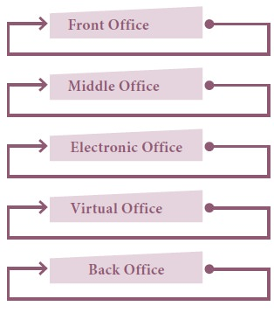
ii. The Middle Office:
The middle office is usually a part of operations division of the business unit. These divisions ensure the proper flow of work within the organisation. Middle office generally functions along with the front office and it comprises of departments of financial services. Due to their critical role, it is supervised by the back office managers.
iii. Electronic Office:
It is integrated computer systems designed to handle office work. In this office all the activities are carried out with the help of software applications. The aim of e- office is to reduce paper work and speed up business operations. The introduction of e-office improves accuracy and efficiency of organizations and thereby improved their level of service. All modern offices are electronic offices.
iv. The Virtual Office:
“Virtual Office” implies mobile or remote work environment equipped with telecommunication links and basic office furniture, but without a fixed office space. Office automation has led to the development of virtual office concept. It works just like a physical office but without physical space and facilities. Employees interact with others through portable communication tools such as electronic mail, cellular phone, voice mail system, laptop computer, fax machine, and audio/video conferencing system. Employees armed with these tools can perform their work from any place — their homes, cars, restaurants, airports, customers’ offices, and so on.

v. Back Office:
These offices are generally found in operating corporate organisations where tasks dedicated to operating the company are performed. The term comes from the building layout of early organisations here the front office would contain the sales and other costumer-facing staff and the back office would be those manufacturing or developing the products or involved in administration but without being seen by customers. Although the operations of back office are usually not given a lot of consideration, their contribution to the business is significant.

KINDS OF SECRETARIES:
On the basis of the nature and functions of secretaries, we classify them as follow:
- Ministry’s or Department’s Secretary:
Every Government Department has a secretary and he acts as the executive head of the department. Secretary is the person who implements the decision taken by the department heads’ He has to advise the Ministers in certain matters. The important functions performed by him include administrative function, advisory function, formulation of policies etc. Usually I.A.S officers are appointed as secretary to top level executives in certain organizations.
2. Private Secretary:
Secretary or personal secretary is a person appointed by a person in high position such as Ministers, senior doctors, lawyers, Accountants etc., whose work requires close attention and cannot afford to spent time for routine activities. He keeps the confidence of his master and he is the right hand man of his employer.

3. Secretary of an Association or a Club:
An association or a club is formed to serve some common cause of its members, such as promoting art, science, music, sports, etc. The secretary of an association is generally elected from the members of the managing committee. Some association appoints whole time directors to look after the day-to-day activities. He acts as an agent and advisor to the managing committee.
4. Secretary of an Embassy:
This is an official of an embassy or a diplomatic mission ranking next to the Ambassador. He is his country’s representative in the country to which he is posted and acts as a link between his embassy and the Government of the country in which it is located. He has to perform administrative and executive functions, and project his country’s image truly and faithfully.
5. Secretary of a Trade Union:
Every trade union has a secretary. The functions of the secretary of a trade union vary with size and type of the union. He has to look after the functions of the union. He acts as a link between the trade union and the management.
6. Secretary of a Co-Operative Society:
The chairman of the co-operative society is considered as the chief executive and the secretary manages the day-to-day administration of the society. The secretary of the co-operative society may be appointed on part time or full time basis depending on the size of work of the society. He wants to maintain proper records and registers and submit periodical statements to the Registrar of the co-operative societies.
7. Secretary of a Local Body:
Corporations, municipal councils, District boards etc. usually appoint whole time secretary to look after their day-to-day affairs. The secretarial duties include office management, assisting to conduct meetings, recording the proceedings etc.
8. Secretary of a Company:
The secretary of a company is the chief administrative officer of the company. Company secretary is a person who is a member of the Institute of company secretaries of India. He act on behalf of directors of the company and represents the company to outsiders. He has to conduct meeting and maintain minutes of the meeting.

UNIT –II

The role of an office secretary -Duties and responsibilities- Usage of different devices - Flowchart and office manuals – Coordinating different wings of an office/organisaton – Arranging common meetings - Operations of banking and financial services - travel and hospitality management services.

An Office Secretary maintains the smooth running of an office through a variety of administrative and clerical duties. They handle office schedules, coordinate meetings and visits, organize files, answer phones and perform a huge array of other essential tasks. Office Secretaries generally work directly for organization or office management, and depending on their experience may also supervise other clerical staff.

OFFICE SECRETARY DUTIES AND RESPONSIBILITIES:

Secretary duties and responsibilities
A secretary's duties can vary depending on where they work, and sometimes secretaries exceed their job requirements.
- Answering and directing phone calls
- Organizing and distributing messages
- Maintaining company schedules
- Organizing documents and files
- Greeting business clients and guests
- Documenting financial information
- Maintaining and ordering office supplies
- Scheduling meetings and conferences
- Assisting executives with project tasks
- Supervising staff and new employees
- Coordinating with other organizations
- Implementing administrative procedures

1. Answering and directing phone calls
Secretaries may be responsible for answering office phone lines and directing each call to the appropriate individual. Oftentimes, secretaries are the individuals that handle solicitation calls, client calls and taking messages. For instance, a legal secretary may regularly take calls from clients regarding casework or other information, and they need to be able to direct each client call to the appropriate attorney, as well as taking and distributing other messages and correspondences. A secretary may also need to have expertise in differentiating between urgent and less important communication.

2. Organizing and distributing messages
Another essential task secretaries may commonly perform is organizing and distributing memos, notes, messages and other written communications. Additionally, secretaries may have exceptional communication and analytical skills to take on communication tasks like these. For example, an executive secretary who works for a CEO of a large technology corporation might be expected to organize and disseminate various messages or memos to bring only the most urgent communications to their CEO. An urgent message might relate to a change in a client's contract, and the executive secretary needs to be capable of quick and efficient communication as they pass messages along.

3. Maintaining company schedules
Secretaries are also commonly in charge of maintaining the schedules and agendas of professionals in their companies. For instance, a secretary for a large marketing firm might organize team schedules for each of the company's departments as well as the executives' agendas by setting appointments with clients, vendors and shareholders. Secretaries may also be the individuals that keep staff on track with reminders and alerts for upcoming conferences or meetings.

4. Organizing documents and files
Keeping documents, records and files organized is another important task that secretaries can be expected to perform. For instance, a medical secretary may commonly take charge of maintaining a filing system for patient medical records, expense reports for medical supplies and medications, procedural documentation and other important documents. Oftentimes, a company's documents, files and other records are stored within a computer database, and secretaries may frequently be expected to have the technical skills necessary to use these types of filing systems.

5. Greeting business clients and guests
Secretaries may also take on receptionist duties in addition to their administrative responsibilities. For example, an executive assistant may act as a receptionist to greet clients who arrive for conferences or meetings and might be the individual who helps visitors get settled, brings refreshments, takes notes during meetings with clients, and generally works to maintain the professionalism and overall brand image of their company when greeting and directing visitors.

6. Documenting financial information
Another highly essential task that secretaries may take on is the documentation of expenses, earnings and other financial information. For instance, a secretary at a sales corporation might be responsible for documenting the revenue and sales numbers from the sales team's reports as well as the company's expenses and costs of operation. The secretary might then use spreadsheet software to organize financial data into specific financial reports for the company's CEO to analyze and approve.

7. Maintaining and ordering office supplies
Secretaries may also be the individuals responsible for keeping inventory records and maintaining office supplies. The secretary may also be responsible for putting in orders for supplies that are running out. For example, an office administrator might make a monthly spreadsheet to keep a running record of the number of supplies like copy paper, toner, pens, filing folders and other supplies to keep track of which supplies are needed and which supplies are sufficiently stocked.

8. Organizing and conducting meetings
Along with scheduling meetings and conferences, secretaries may also take on the responsibility of organizing and conducting meetings. For instance, an executive secretary for a CEO of a retail corporation might organize a meeting with clothing designers, fashion brands or other professionals in the industry. Then, the secretary may conduct the meeting by discussing the important points of the conference and taking notes for the CEO and other decision-makers at the company. Secretaries can be a vital team member in performing these types of tasks, as executives, directors and other high-level professionals may sometimes be unavailable in similar circumstances.

9. Assisting executives with project tasks
Sometimes a secretary can be invaluable in assisting their supervisors with completing small tasks as part of larger projects. For example, a secretary for a lead marketing director might assist by organizing reports, printing documents or preparing a presentation. Because of the range in tasks a secretary might perform, this type of professional must possess a wide range of soft and hard skills to succeed in the role.

10. Supervising staff and new employees
Secretaries might also be the mentors who work with staff when implementing procedures and when training new employees. Because of their knowledge and experience with their companies, many secretaries help lead staff and new hires in developing their skills, following company protocol and learning about the overall company environment. As an example, a legal secretary might take on mentoring a newly hired paralegal and show them how to use the firm's computer and filing systems, how to organize casework and documents according to policy and the methods staff uses to complete tasks and handle clients.

11. Coordinating with other organizations
Secretaries also work to coordinate and form relationships with other businesses and organizations. For instance, a secretary for an engineering firm might be the liaison that connects with contractors, designers and other engineering organizations to set up conferences, purchase resources or form business partnerships.

12. Implementing administrative procedures
Secretaries might also play a role in developing and implementing company policies and various administrative procedures. For example, a medical secretary may develop a procedure for documenting patient treatment plans that includes following a set of steps to document medical information in a database. The secretary might then implement this new procedure by training nurses and staff on how to carry out the directives of the policy.

FLOWCHARTS OF OFFICE SECRETARY:

Flow of work is concerned with the way work move along with one operation to another. It denotes the volume of work going through the rate at which it moves along and the smoothness of its passage.
The flow of work aims at greater efficiency in every office activity, so that costs are cut down and delays are eliminated. Flow of work is a problem to be solved by the managers.
Flow charts are prepared for the purpose to know whether the flow of work is ideal or there is scope for improvement. The following types of flow charts can be used for analysis.

- Office Layout Chart.

This chart analyses the flow of work of each part of office and eliminates waste motion & back tracking. In the chart, lines are drawn to indicate the movement of
office forms and documents from operation to operation.

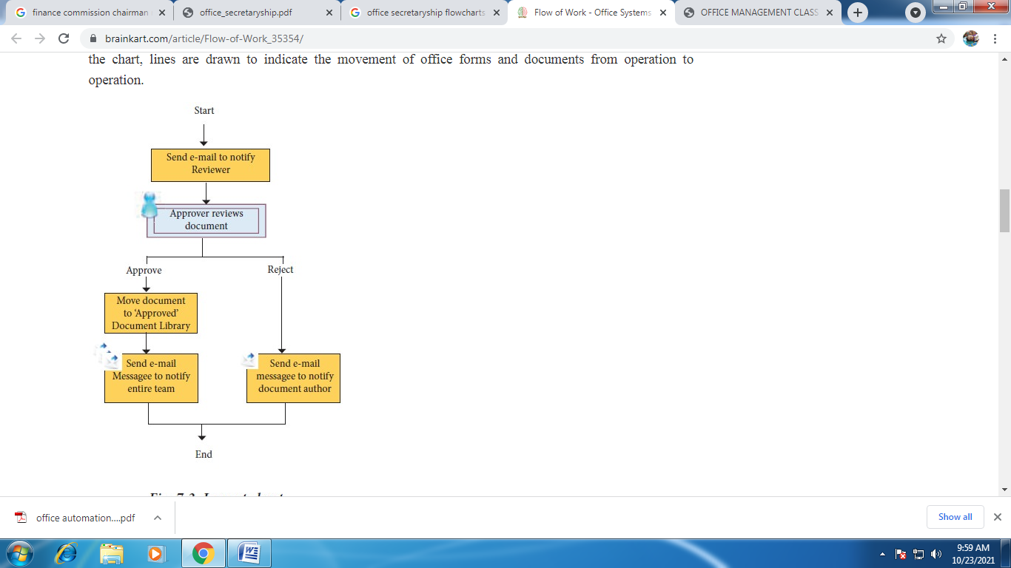

b. Flow Process Chart:
Process chart is also known as work simplification chart. By using certain standard symbols, the chart shows the flow of work under a specific procedure. Presentation and reading is easy because the charts are more graphic with symbols.
It helps to simplify the work. These standard symbols have been developed by the American society of mechanical engineer, New York.
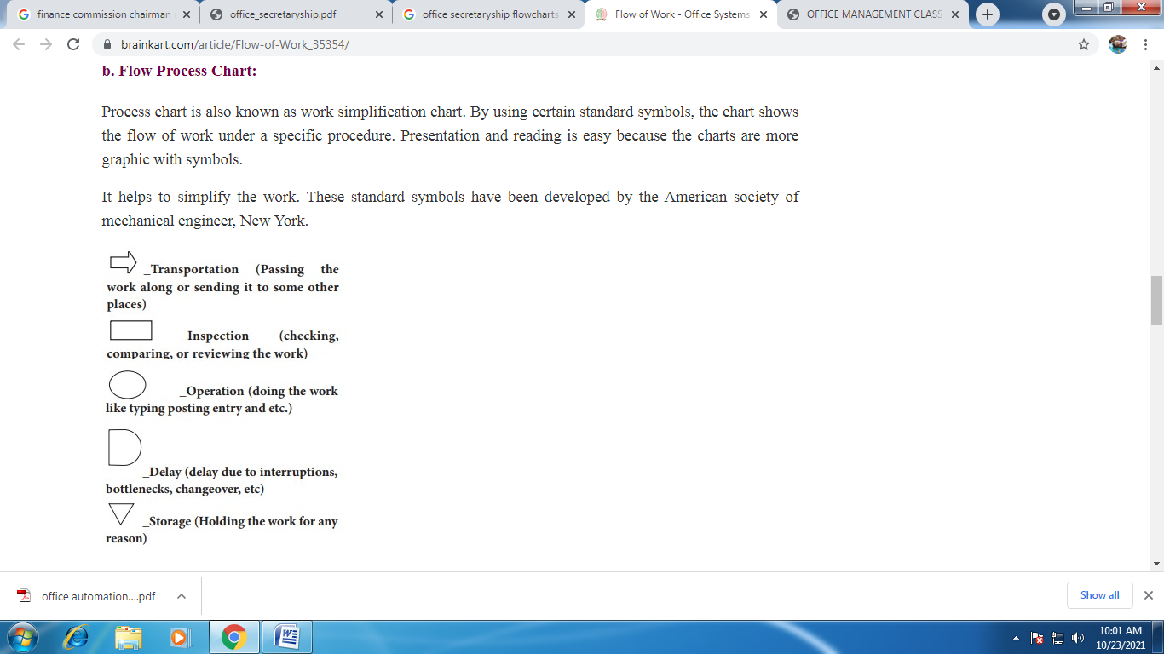

c. Management Type Flow Chart:
Management type flow chart is fully illustrated chart and each operation or steps involved are described in short and descriptive sentence. The chart is written and read horizontally from left to right.

Straight-Line Flow of Work:
Smooth flow of work can be ensured by the use of straight-line flow of work method. This method is applicable for the factory as well as the office. It can be described as the method, in which the work flows, while progressing from one operation to another, it should follow a course approximating as nearly as may be possible in a straight line. In order to avoid the wastage of time, effort and delay in the flow of information, the work must always move forward and in a straight-line.

BENEFITS OF STRAIGHT-LINE FLOW OF WORK:

The following are the list of benefits of Straight-line flow of work:
1. Greater Speed: The speed of work increases greatly, since the movement of work is over the least area.
2. Lesser Messenger Work: Since the work is flowing in a straight-line, the desks can be arranged in a straight-line, the distance between the different operations is small and the papers or files are passed over from one desk to another by the clerks is easy. It reduces the messenger work.
3. Less Loss of Papers: In this method, papers are rarely mislaid or lost as they are handled in a systematic manner.
4. Use of Conveyors: In certain organization conveyors are used to transfer the files from one place to another, such an arrangement helps to speed up the work.
5. Keeps Executives and Clerks at Their Desks: As the work moves in a straight-line, this method avoids moving here and there unnecessarily and makes the employees to sit in their chair to do the work.

PROBLEMS IN SMOOTH FLOW OF WORK:

Smooth flow of work faces number of problems, which must be tackled in order to improve the efficiency of office routine. It can be solved only by the managers. The problems are outlined below:
1. Unequal Flow of Work: The work in the office cannot be equal throughout the day, the week or the year. The work may be heavy on particular day in a week or it may be heavy during a particular period. For example, there may be greater incoming mails in the morning and on Mondays. The problem of unusual flow of work can be solved by collecting relevant statistics and their analysis.
2. Interruptions to Work: The interruptions to work are internal or external. Internal interruption may be caused by lack of materials with which to work, information needed is not available or because of change of work through change of plan, etc. External interruptions to work may be caused by outsiders calling the employees and external telephone calls.
3. Unequal Times Needed for Different Operations: This is the major problem in the flow of work where, different operations of a job need different time to complete. For example, the sequence of operations for the first operation may require one minute, while the next may require three minutes.
4. Lack of Standard: Steady flow of work may also be affected, if the work to be done by an individual that can not equal to the standard fixed. In the absence of standard, some employees may over burden with heavy work while the others may have less work.
5. Lack of Planning and Scheduling: If the office manager does not plan and schedule the work before time, it is not possible to do the work quickly or not to do the work within the allotted time.
6. Faulty Layout: Steady flow of work may be affected if the layout of the office is not made according to a well-developed plan. Criss-crossing and back tracking procedure will affect the flow of work.

OFFICE MANUALS:
The office manual contains the details of the work to be performed in an office and other important particulars of the organization. It is the source of information, knowledge of which is essential for the performance of the work. It may be in the form of a book or booklet and contains the information which benefits the office staff. If Office employees are supplied with copies of office manual they do not have to approach their superiors again and again. Therefore, they do not interrupt the work of their superiors and there is no wastage of time to office employees (new entrants) as well as to executives (Superiors).

Meaning of Office Manual:
An office manual means a handy form of book or booklet containing information relating to the policy, organization system, routines and procedures, methods and standards and the rules and regulations regarding employment.
An office manual is prepared to help the employees know all relevant information regarding the organization, its set up i.e. structure and how he fits into it.

Definition of Office Manual:

According to George R. Terry, An office manual is a “written record of information and instructions which concern and can be used to guide the employee’s efforts in an enterprise”.

Also, an office manual has been defined as “a document disclosing the information about an organization, its set up, conditions of employment, and the established systems, routines, procedures, methods, standards, rules and regulations of an office operation.”

Need for Office Manuals:
A large size organization has a number of branches or departments or sections or divisions. Thousands of employees are employed in large size organization. Hence it is very difficult to control the employees by the management. If instructions or guidelines are given in writing to the employees, the management can control the employees very easily and avoid misunderstanding of employees.

Office manuals help the management and the employees in various ways.
- Employees understand their position, duties and responsibilities in an Organization.
- Employees understand their role in the achievement of office Objectives.
- There is a possibility of maintaining good relations among the employees by themselves.
- Both existing and new employees freed the management in getting the same information, explanations and instructions repeatedly.
- The concerned employees are held responsible if the duties are not performed by them in a specified manner.
- Delegation of authority can be enhanced throughout the organization set up without much difficulty.
- Each employee can understand the extent of authority delegated to them.
- New employees are getting training with the help of office manual by knowing policies, practices, systems, routines and procedures.
- Office manual is imparting refresher training to existing employees.

TYPES OF OFFICE MANUALS:

1. Policy Manual: Every organization has its own policy which is served as basic guide to action. The entire activities of an organization are fully guided by policy manual. A policy manual contains decision, resolutions and directions of the board of directors stating the policies of the company.

2. Organizational Manual: The organizational manual describes the organization structure. The duties and responsibilities of each employee in department wise or section wise or division wise are explained along with the line of authority and responsibilities connected with them. Each employee can understand the relationship with others. Sometimes, a separate manual is prepared for each department in case of multinational companies.

3. Administrative Practice Manual: Standard methods and procedures for effective performance of work are given in this manual. Separate methods and procedures are given for each department specifically, if needed. This manual also contains guidelines and instructions on education required to an employee and training to employees, format of correspondence and reports, and the inter-relationship of office employees.

4. Departmental Practice Manual: This manual deals with policy of the concerned department, methods and procedures followed in the concerned department. This type of manual is prepared for each department separately.

5. Mailing Manual: A mailing manual gives detailed instructions in all phases of handling both incoming and outgoing mail. The letter drafting procedure is also given in this manual.

6. Filing Manual: The names of the files to be maintained in an office are given in this manual. Besides, the preparation of title and its maintenance are also clearly discussed.

7. Rules and Regulations Manual: Rules and regulations are very much important to every office employee. Everybody should work according to the rules and regulations. Various types of leave are availed by the office employees. The number of such leave and their availing procedure are given in this manual.

8. Historical Manual: An employee should know something about his enterprise. This manual contains brief history of an enterprise. Name and address of the enterprise, founders, objectives for establishing such enterprise, circumstances under which the enterprise is established, capital required and contributed by the founders, registration, coverage of law etc are briefly discussed. This information is highly useful to new entrants in an office.

9. Multi-Purpose Manual or Hand Book: Some offices prefer to have a single manual instead of several manuals such as discussed above; If so, only relevant and important information are combined in the form of a hand book. In such a way, multi-purpose manual is prepared.

The information included in a manual of one office may not be the same of another office. In other words, the contents of a manual are according to the needs and preferences of the concerned office.

STEPS IN PREPARATION AND WRITING OF OFFICE MANUALS:
A standard and an orderly procedure should be followed while preparing office manuals. If so, the prepared manual can ensure complete, accurate and comprehensive. The preparation is to be completed within a reasonable period of time. The following steps may be taken while preparing an office manual:

1. Assigning an Individual or Formation of a Committee: An individual is enough to prepare an office manual in small size organization. A committee has to be formed to prepare an office manual in case of large size organization. So, this formality is carried on according to the size of the organization.

2. Preparing the List of Subjects Covered: The responsible executives prepare the list of subjects to be covered in the preparation of office manual. List of subjects vary according to the type of manual preparation. The subjects and topics to be covered should be classified and arranged into logical headings and sub-headings.

3. Receiving Ideas and Suggestions: Ideas and suggestions have to be received from the managers of functional departments and supervisors as per the subjects covered. A time schedule is to be fixed for receiving ideas and suggestions.

4. Verification of Ideas and Suggestions: Received ideas and suggestions have to be tabled and verify the same. Irrelevant and impracticable ideas and suggestions have to be rejected with due care.

5.Classification and Arrangement of Information: The collected information and data have to be classified and arranged under each subject and write them up in subject-wise. The information and data included should be accurate and complete in all aspects.

6. Prepare a Draft Manual: A draft manual is prepared by considering the relevance of the concerned manual. A limited number of copies of such draft manual is typed or cyclostyled for circulation. A copy of draft manual is circulated among the office manager, functional manager, union representatives and top management executives for their criticism. Such criticism is used for the betterment of the preparation of office manual.

7. Revision of the Draft Manual: Suggestions and criticism have been incorporated in improving the manual by adding new points or deleting some points. The style and standard of language can be improved by the process of revision of the draft manual. As for as possible, short sentences and words can be used. The language should be simple and direct.

8.Submission for Approval of Top Management: The revised manual has been placed before the top management for approval. Approval of top management is necessary before the production of the manual.

9.Mechanical Production of the Manual: Arrangement for the production of the manual should be made after the draft is approved by the top management. The type of production of manual is depending upon the number of copies required. Details regarding size, paper cover and binding should be considered before the actual production of manual. The manual should preferably be in a booklet form.

10.Distribution of Office Manual: Copies of office manual are distributed among the employees of an organization on need basis. A few copies are maintained as spare copies which will be used for the future reference and further revision of the manual.

ADVANTAGES OF OFFICE MANUALS:

The advantages of Office Manuals are

1. It contains printed instructions and all the important decisions for the execution of the work, so the employees don’t want explanation for the work again and again.

2. It gives readily available printed instruction about system, procedure and duties existing in the organization, so it is easy to train the employees.

3. In large organization which is having many branches, similar type or uniformity of activities can be performed if they have manual

4. The entire work of an office is brought together, studied, examined and incorporated in office manual, so that the activity having less importance can be eliminated.

5. It helps the executives to take decision promptly by referring instructions and policies contained in printed form.

6. When the rules and regulations are in the written format it is easy for the employees to get an idea about their responsibility, duties and authorities. It helps to improve good relation between the employees.

7. When the employees are transferred from one office to another office,with the help of manual they can start their work without delay.

DISADVANTAGES OF OFFICE MANUALS:

The disadvantages of Office Manuals are:

1. To keep the manual up-to-date is a difficult job
2. It is costly and time consuming process, so it is difficult to have manuals in small firms.
3. If simple words are not used in manuals the employee reading can misinterpret it.

OFFICE MANAGEMENT AND SECRETARYSHIP : BANKING AND FINANCIAL SERVICES
MODERN BANKING SERVICES:
After Liberalization, Privatization and Globalization, there was a huge development taken place in the Indian banking scenario. All Indian banks were forced to compete with world banks that were permitted to open their branches in India. As a result, all banking customers were offered multiple and model banking products which are different from traditional and conventional banking system in India and these banking functions or mostly based on information technology.
Such modern banking services include new products such as Core Banking Solutions; No frills account; Demat accounts; Net Banking/ E-Banking; Mobile banking; Debit Card/ Credit cards; Automated Teller Machines (ATM); Insurance etc.
1. Core Banking Solution (CBS):
Core Banking Solution (CBS) is networking of branches, which enables Customers to operate their accounts, and avail banking services from any branch of the Bank on CBS network, regardless of where he maintains his account. The customer is no more the customer of a Branch. He becomes the Bank’s Customer. Under this system all CBS branches are inter-connected with each other. Therefore, Customers of CBS branches can avail various banking facilities from any other CBS branch located anywhere in the world. This CBS helps the customers
- To make enquiries about the balance or debit or credit entries in the account.
- To obtain cash payment out of his account by tendering a cheque.
- To deposit a cheque for credit into his account.
- To deposit cash into the account.
- To deposit cheques/cash into account of some other person who has account in a CBS branch.
- To get the statement of account.
- To transfer funds from his account to some other account – his own or of third party, provided both accounts are in CBS branches.
- To obtain Demand Drafts or Banker’s Cheques from any branch on CBS – amount shall be online debited to his account.
- Customers can continue to use ATMs and other Delivery Channels, which are also interfaced with CBS platform.
2. No Frills Accounts:
These accounts are opened mostly in rural areas as a part of financial inclusion project encouraged by Reserve Bank of India. These accounts are opened by banks without the condition of maintaining minimum balance. No charge will be levied for non-operation/activation of inoperative basic savings bank accounts. No frill accounts are mainly aimed to take the banking facilities to the poor people in the unbanked rural areas and semi-urban areas.
3. Demat Accounts:
These are maintained by banks for high value transactions which are maintained in electronic forms for dealing in shares and securities of the customers mostly dealing in Government Bonds.

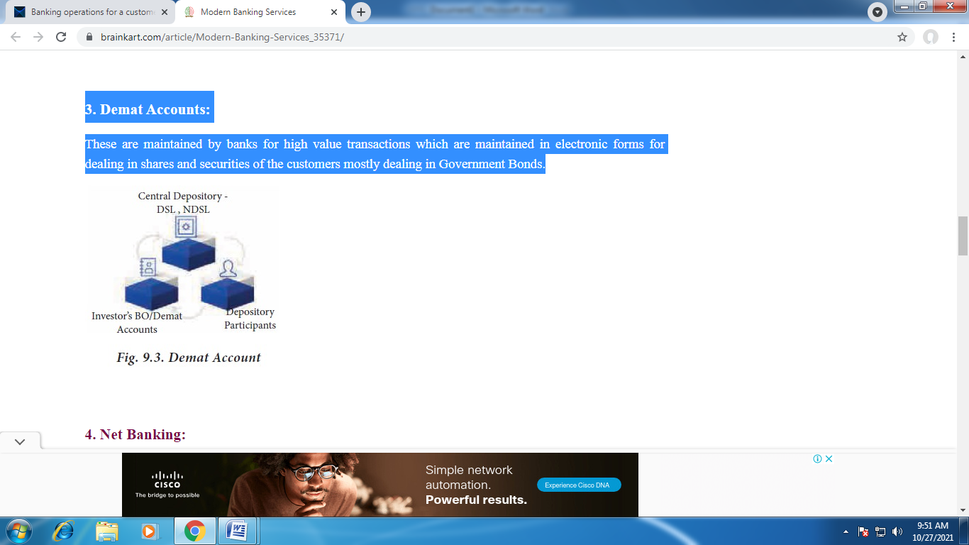
4. Net Banking:
This is the easy way of doing banking from the convenient place of the customer and avoids queue or delay. We can also check balance,transfer funds, pay bills, open fixed and recurring deposits etc. Each customer is given a unique user ID and password for the purpose of accessing internet banking. Electronic Banking is also known as Electronic fund Transfer. Electronic means to transfer funds from one account to other account by ways of NEFT, RTGS or IMPS.
- NEFT- National Electronic Fund Transfer
- RTGS- Real Time Gross Settlement
- IMPS-Immediate Payment Service

5. Mobile Banking:

Mobile Banking is a service provided by banks or other financial institution that allow their customers to do financial transaction using mobiles like smart phone or tablet. It is quick and simple way of banking. Mobile banking app helps to check the account balance, transfer funds, pay in bills etc.

6. Debit Card / Credit Card:
A debit card is a plastic payment card that can be used instead of cash when making purchases. It is similar to a creditcard, but unlike a credit card, the money debited directly from the user’s bank account when performing a transaction. It is also known as a bank card, plastic card or check card.
In credit card, in the customer can perform the transaction upto a predefined limit, and pay them to the bank before a specified date.
7. ATM (Automatic Teller Machine):
This is an electronic device which helps the customers for withdrawal, deposits money, transfer fund etc, round the clock. For Availing the services of an ATM the customer need ATM card with PIN number (Personal identification number). It provides 24 x7 and 365 days a year service.

8. Insurance:
Insurance is a means of protection from financial loss. It is an arrangement by which the company undertakes to provide a guarantee of compensation for specified loss, damages, illness, or death in return for payment of specified premium. The largest insurance company in India is owned by government.

9. Lock-Box and Night Safe Services:
These services are provided by some banks. Lock-box helps the customers particularly the traders, to keep cheques and other remittances in a box for next day collection and certain entries should be passed. Nightsafe service is useful to the traders who receive large amount of money after the banking hours and who feel insecured at their premises.

FINANCIAL SERVICES:
There has been an upsurge in the financial services provided by various banks and financial institutions since 1990. Efficiency of emerging financial system depends upon the quality and variety of financial services provided by the banking and non-banking financial companies. Financial services, through the network of elements such as financial institutions, financial markets and financial instruments, serve the needs of individuals, institutions and corporates. It is through these elements that the functioning of the financial system is facilitated.

Indian financial service industry was dominated by commercial banks and other financial institutions which cater to the requirements of the Indian industry. Infact the capital market played a secondary role only. The economic liberalization has brought in a complete transformation in the Indian financial services industry. Prior to the economic liberalization, the Indian financial service sector was characterized by so many factors which retarded the growth of this sector.

Some of the significant factors were:
- Excessive controls in the form of regulations of interest rates, money rates etc.
- Too many control over the prices of securities under the erstwhile Controller of Capital Issues
- Non-availability of financial instruments on a large scale as well as on different varieties.
- Absence of independent credit rating and credit research agencies.
- Strict regulation of the foreign exchange market with too many restrictions on foreign investment and foreign equity holding in Indian companies.
- Lack of information about international developments in the financial sector.
- Absence of a developed Government securities market and the existence of stagnant capital market without any reformation.
- Non-availability of debt instruments on a large scale.
The financial intermediaries in India can be traditionally classified into two:
- Capital market intermediaries
- Money market intermediaries
Financial services cover a wide range of activities. They can be broadly classified into two namely:
- Traditional activities
- Modern activities

Traditional activities: Traditionally, the financial intermediaries have been rendering a wide range of services encompassing both capital and money market activities. They can be grouped under two heads viz;
- Fund based activities and
- Non-fund based activities
Fund based activities : The traditional services which come under fund based activities are the following:
- Underwriting of or investment in shares, debentures, bonds etc. of new issues (primary market activities)
- Dealing in secondary market activities.
- Participating in money market instruments like commercial papers, certificate of deposits, treasury bills, discounting of bills etc.
Non-fund based activities : Financial intermediaries provide services on the basis of non-fund activities also. This can also be called “fee based” activity. Today, customers whether individual or corporate are not satisfied with mere provision of finance. They expect more from financial service companies. Hence, a wide variety of services, are being provided under this head.
They include the following :
- Managing the capital issues i.e., management of pre-issue and post-issue activities relating to the capital issue in accordance with the SEBI guidelines and thus enabling the promoters to market their issues.
- Making arrangements for the placement of capital and debt instruments with investment institutions.
- Arrangement of funds from financial institutions for the clients’ project cost or his working capital requirements.
- Assisting in the process of getting all Government and other clearances.

Modern activities: Besides the above traditional services, the financial intermediaries render innumerable services in recent times. Most of them are in the nature of non-fund based activity. In view of the importance, these activities have been discussed in brief under the head ‘New financial products and services’. However, some of the modern services provided by them are given in brief hereunder:
- Rendering project advisory services right from the preparation of the project report till the raising of funds for starting the project with necessary Government approval.
- Planning for mergers and acquisitions and assisting for their smooth carry out.
- Guiding corporate customers in capital restructuring.
- Acting as Trustees to the debenture-holders.
- Recommending suitable changes in the management structure and management style with a view to achieving better results.
- Structuring the financial collaboration/joint ventures by identifying suitable joint venture partner and preparing joint venture agreement.

OFFICE SECRETARY FUNCTION IN TRAVEL AND HOSPITALITY

A fantastic part of travelling is experiencing new forms of transportation, all while trying to figure out how to get from point A to point B on your itinerary. Sometimes it works out and other times you have to keep an open mind if you end up getting lost

1. Walking
The easiest (and cheapest) form of transportation is to just walk. A lot of cities are super easy to explore on foot. Being on the streets lets you see a lot of cool and beautiful architecture, experience the people around you, and take more of the city in than compared to being in the back seat of a taxi or behind closed doors on a subway. Just make sure you to look out for bikes/cars and always use crosswalks when crossing streets.

2. Biking
Do a quick google search and see if you’re travelling in a city that is biker friendly. It’s a bit faster than walking and super fun. Many of the major cities will have a bike sharing service, such as Donkey Republic (major European Cities), CitiBike (NYC), and Divvy (Chicago). Another option is taking a bike tour of a city. Just don’t forget to rent a helmet!

3. Cars
Whether you rent a car, drive your own, use a ride share app, or take a taxi, driving is another simple way to travel around. Especially in big cities you may not be the most familiar with, hopping in an Uber, Lyft, or taxi may keep you from getting lost. Road tripping is another incredible way to travel around. You can check out a few previous BTB articles, giving you tips on staying fresh on the road and ideas on how you can live out of your vehicle.

4. Trains
Trains are a nice and easy way to get to where you need to go. Whether you’re commuting to a city or going home from RIT for a school break; trains are roomy, convenient, and give you some time to relax. Remember to bring something to do such as a book to read, music, or a movie if you have a long trip ahead of you. Some trains even have WiFi and other commodities. During my daily commute into Copenhagen for class, one of my favourite things to do was watch the scenery pass outside my window. Just make sure to always have your ticket handy if a ticket inspector comes by.

5. Buses
Whether you’re taking a public bus, a charter bus across a country or a hop-on-hop-off tourist bus, there are a few things to remember. For public transportation, always have cash or coins to pay for a ticket when you board (it’s rare they take credit cards) and hit the stop button before your stop to indicate to the driver you need to get off. If you are taking a chartered bus, make sure you are on time and double check that you’re getting on the right one. Hop-on-hop-off buses are another exciting way to see a city. They run right on schedule, so don’t be late and always keep the schedule handy.

6. Boats
Some cities have boats included in their public transportation. From huge ferries to small boat tours, this mode of transportation provides a unique view of the city and is definitely worth checking out. Some European countries offer ferry rides from country to country, giving you an interesting and unique alternative to flying. If the city you’re visiting is surrounded by water, check out some boat tours, and see what types of excursions are offered. Spending a little extra money for a boat tour (or even a sailing trip) will help you you’ll learn a lot about the area, get awesome pictures, and have loads of fun.

7. Flying
Flying is a great way to get yourself to a major city and start your adventure. Airplanes get you places fast and are the most versatile mode of transportation, taking you across states, across countries, and across waters. It’s good to pack some snacks, a neck pillow, and definitely, something to do on a flight…no matter the distance. If you are planning on taking a long flight, you can read a previous BTB article giving you some pointers on how to survive the trip.
HOSPITALITY:

Hospitality is the relationship between the guest and the host. It is the act/practice of being hospitable including friendly generous reception/welcoming of guests, their entertainment and providing services with warmth and courteousness. It is basically concerned with providing a place to stay, food, entertainment and other facilities to make the stay comfortable.
Different types of establishments offer hospitality services e.g., hotels, motels, lodges, resorts, and furnished apartments.
- A hotel is a commercial establishment offering lodging, meals and other services to its guests.
- A lodge offers rented accommodation especially for sleeping and may not offer food and other services.
- A resort is known for its leisure attraction. It offers a broad range of amenities, sports facilities and leisure activities for ensuring a total vacation experience.
- Furnished apartments provide all essential amenities needed by the guests.
- Furnished camps provide hospitality to people who go hiking, undertake adventure sports etc.
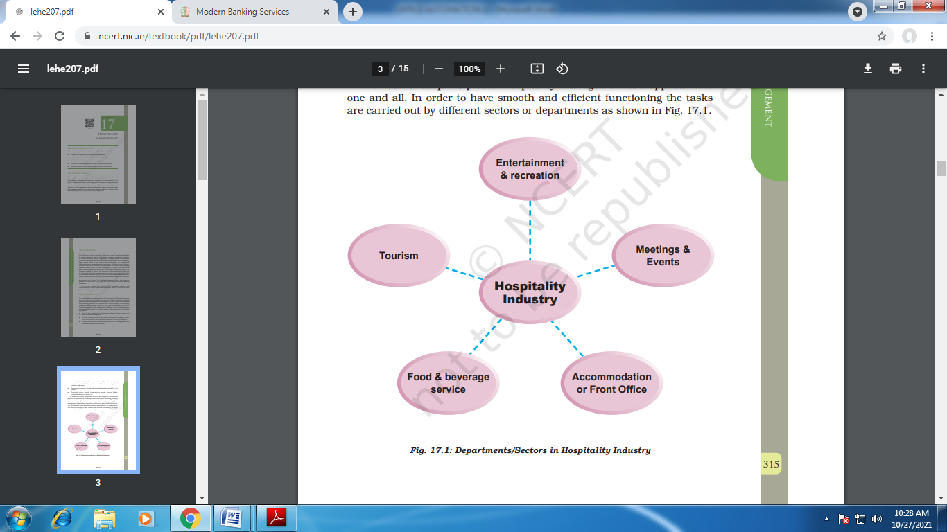

In order to have a better understanding of the different departments it is necessary to understand the concept of “Guest Cycle”. What is the Guest Cycle? The “Guest Cycle” starts even before the guests physically steps into a hotel and it consists of four stages
- Pre-arrival stage — The activities done in the pre-arrival stage include:
- quoting rates for a guest
- Reserving a room as a part of central reservation system or reservation department.
- Arrival Stage —
In this stage, as the title suggests, the guest actually arrives and registers or checks-in.
- Occupancy —
This stage consists of providing various services as per the guest’s requirements, ensuring security of the guest and coordination of various guest services. Guest satisfaction is the main focus in order to ensure and encourage the guest to patronise and use the services of the establishment again; in other words, to obtain and retain ‘customer loyalty’.
- Departure —
This is the final stage of the Guest Cycle where the guest is ready to leave/move out or “check-out” of the accommodation. An up-to-date record of the room occupancy of the guest is kept along with other information about the guest known as ‘guest history’
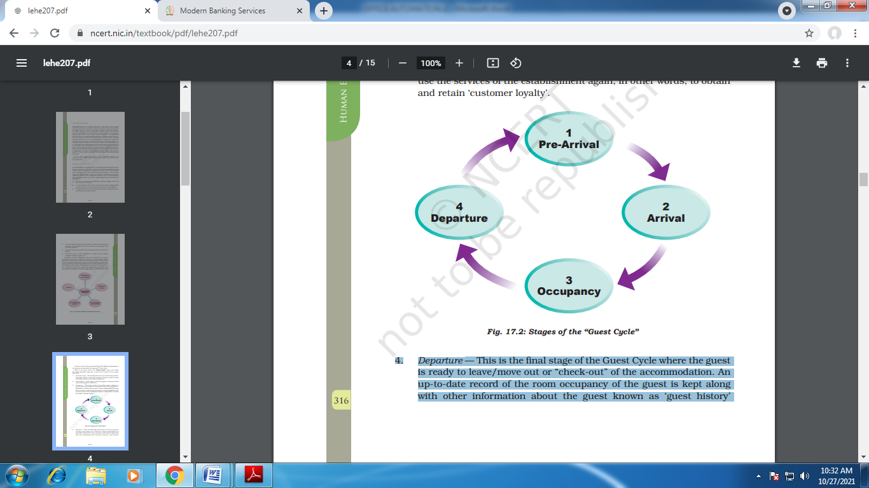

Coordinating different wings of an office/organisation:

The duties of secretary to the office have an early start. As the secretary belongs to the top management group he is in the process of overall policy-making including the policy in respect of office administration. The composition and functions of an office largely depend on the nature and extent of the functions of the organisation.
The secretary is an advisor to the management and generally he is entrusted with the administrative part of management as a whole so he she is coordinate the different departments by following below duties
(a). Planning and organizing: Planning for and organising the office, which are the functions of the top management group, may be entrusted on the secretary.
Such functions are:
1. The primary duty of the secretary is to prepare the Organisation Chart for the office, Determining the different positions to be held and their levels. At the same time job grading has to be finalized. The number of employees has to be estimated by him and a recruitment policy also to be decided. Together with the organisation Chart an Office Manual also has to be prepared clearly defining the authority of each position and its functions.
This is very helpful to avoid
a. Indetermination and confusion
b. Overlapping of authority and
c. Conflict among the members of the staff
with planning also comes, preparation of budget fo the establishment cost of the office, both present and future.
2. The secretary will now decide what system should be followed in office organisation a system of centralisation or a system of decentralisation. A wise blending of the tow systems will be ideal.
3. Next come the lay out of the office. Definitely the modern open type of lay out will be preferred by, the secretary. Much depends on the system to be followed and the shape and size of the available accommodation.
4. Now the stage is set for the secretary for establishing and running the office. Recruitments have to be made and equipment of all types have to be procured under his supervision and guidance.
5. The secretary will divide the office into functional departments man the deprtments and assign duties to the memebers of the staff. Appropriate authority together with corresponding responsibility will be delegated to each member of the staff. If necessary, training will be arranged for them

B. Supervision And Control: supervision and control are not identical terms. Supervising means just overseeing whether the subordinated are doing their duties or not . Generally it is done by the office manager. Controlling is a bigger function.
It entrails:
a. Fixation of standard of performance
b. Evaluation of actual performance
c. Verification of actual performance with the standard
d. Rectification of errors, if any, so that they are not repeated

1. The secretary is more than a mere office manager and so he has both the duties to perform-supervision and control. When there is no office manager, he may be assisted by supervisors. He may not have control over the departmental managers like production manager, marketing manager, etc. Who are doing the main functions and known as ‘line’ people. They may be under the General Manager.

But the ‘staff’ people who are the heads over the service functions like the Personnel Manager, Finance Manager, etc. are generally under the direct control of the secretary. Whatever may be the case, the secretay has to control and coordinate the different clerical functions connected with the general or centralised office.
2.He has to maintain a continuous liaison between the top management and the other employees of the organisation as well as with the Government and the outside people interested with the concern. He has to maintain liaison between the organisation and the public at large. This he carries on from the office.
3. He has to maintain a coordination between the head or the main office and those of the branch divisional offices, if any
4. He has to maintain continuous supply of office equipment
5. He has to do filing of all statements and documents as required under his statutory duties.
6.He has to arrange all meetings required under statutes or otherwise and do all the needful for the meetings, meetings may be held at the office or elsewhere
7. He has to apply his mind for the improvement of office functions through O & M study and out of his own
8. He has to apprise the top management about the functioning of the office and submit oral or written reports with or without recommendations on the same.

C. General :Sometimes , specially in case of society or association or a small-size concern, much of the clerical functions are directly handled by the secretary himself. Generally, most of the outgoing letters are signed by him. In some officers, the practice is that the incoming mail will go to the secretary first who will look over the papers before they are being distributed among the respective departments.

*****<><>*****

UNIT –III
UNIT III: Office procedures – Filing– Circulating files - Preparation of notes, circulars, agenda and minutes of meetings – Issue of press notes - Maintenance of files and records - Inventory, office, human resources, financial and confidential - maintaining public relations.

OFFICE PROCEDURES :
Office procedures are the set of rules or policies guiding the operations of an office or business. They are the formal process followed by an organization to collect the necessary information for making efficient and effective decisions. Hence, following are the main importance of office procedures:
For performance of office related jobs in organized and uniform way.
For proper solution to organizational problems by listening and implementing the opinions, ideas and information from even lower level staffs.
A Tippani
A Tippani is written statement of facts, information, related rules and regulations, opinions and suggestions. It is prepared by lower level staffs and submitted to higher level staffs for decision making. Since it is used to make important decisions, it should be checked by each authority to ensure the inclusion of all the information and documents.
The objectives of Tippani are as follows:
- To make correct and effective decisions on a particular issue.
- To communicate the current problems regarding particular issue to concerned higher authority.
- To clear the existing unclear rules and regulations or amend them.
- To make decisions based on opinions of all staffs of organization.
Report is the output or conclusion of certain investigations, study or research. Following are the various types of reports:
Annual Report
The report covering the activities, progress and achievements made in a particular year is called Annual Report. It is prepared by all kinds of organizations to measure their performance over the year. In companies, annual report comprising of financial documents is presented at general meeting for approval by shareholders.

Government Report
A government is always accountable to general public. So a report is prepared by government to make people aware about its activities, plans, policies, revenues or incomes, expenditures etc. which is called a government report. Based on this report, people can judge on the efficiency of the government.
Audit Report
A report regarding the preparation and communication of financial information of an organization prepared by the auditor is called audit report. It checks whether financial transactions are carried out within existing rules and regulations. Auditor General and independent auditor prepares the audit report for government organization and public company respectively.
Academic Report
A report prepared by students or academic institution after completion of the examination or study or research is called academic report. The content of the report is related to educational or academic activities.
Committee Report
A committee is group of experts formed to achieve a particular objective by carrying out certain activities. The very report prepared by members of committee after completion of designated job is called committee report. It is submitted to concerned authority for approval and implementation.

OFFICE FILING PROCEDURE
Office Filing Procedure is the process of filing all the clearly defined and pan-organization followed practices in filing documents and important papers. These instruct all the employees on what actions are to be taken in case of certain situations, likely or unlikely. Office Filing Procedures can include Employee Job Descriptions, Workplace Etiquette, as well as certain confidentiality protocols. In this tutorial, we will discuss in detail about the benefits of Office Filing Procedure and how it helps an organization to become proficient.

Definitions of Official Filing
Most often, a wrongly-designed document can spread massive miscommunication and discrepancies between the working departments in an organization. Sometimes, such situations arise for which there no clear procedure was mentioned. Often, there might not have been a set of instructions written on how to deal with an irate customer walking into an office and venting their anger on the manager. However, these scenarios are supposed to be documented later and a filing done on it.
For example, after dealing with a specific customer, the company owner, or the manager might file a protocol that includes informing the immediate supervisor, offering a grievance form, and asking the customer politely yet assertively to remain calm, so that the issue is resolved.

Appendix to Correspondence
The term 'Appendix to Correspondence' refers to the lengthy enclosures to a written communication mentioned or referred to in the file. This part is normally added to the end of the document as a correspondence portion, so that it doesn’t come in the way of a smooth reading of the document.

Appendix to Notes
The term 'Appendix to Notes' refers to the lengthy summarization of all the details of the information that is given in the document on different aspects of the question as discussed. Such details could trivialize the main point or make the main message unnecessarily lengthy.

Department Manager
The Department Manager (i.e., Assistant Manager holding equivalent rank) oversees the Department and in that capacity, he has the right to exercise his power and control regarding the dispatch of information and maintenance of business processes. Work comes to him from the departments under his charge.

Case
A Case refers to the file that has all the important documents currently being considered or referred. It also mentions all the different papers and books that can be used as an accompaniment to the original document to be used as a complementary study, reading or reference.

Comeback Case
A comeback case is used to define a document or report that needs further re-examination and drafting, as the original document was found to be either incomplete or faulty. It is also a summary of the current issue.

Correspondence
Correspondence is the comprehensive and detailed collection of all communications both sent from the organization and received from the different parties. Correspondence can be used to include all three styles of correspondence, i.e. Official Correspondence, Demi-official Correspondence and Unofficial Correspondence.

Current File
A current file is a file that is currently undergoing detail-entry or modification. It differs from a comeback case in that it is a newly-drafted document and not one that is being revised and reworked on.

Dealing Hand
A dealing hand can mean any official such as the Junior Clerk, Senior Clerk, Executive Assistant, etc., who can be given the responsibility of initially examining and noting of the cases.

Demi-official Correspondence
A demi-official correspondence is the one that takes place between two managers or between an organization and the public, which doesn’t follow the usual communication protocols and is conducted to get an opinion from the public on a product or service.

Divisional Manager
A Divisional Manager is a person who can exercise the powers of the equivalent rank to a manager in his absence, and is responsible for smooth functioning of the Department under his charge.

Docketing
Docketing is the action of making entries of serial numbers on the notes-taking area of a file. This is done so that the file can later be easily identified from the mark or the identification number.

Draft
A Draft means a rough copy of the document that is currently being prepared. The word 'Drafting', when used in a Company, usually means composing of official communications of all the notes or orders of the managers. These drafts are usually held for feedbacks and reviews.

File
A File means a collection of papers on a specific subject matter, which is recognized from a specific serial number, or a file number, and has many correspondence notes, and an Appendix to Correspondence.

Filing
Filing is the act of arranging some important documents in a readable and organized manner so that they can be referred to quickly and located in a short span of time without a lot of searching.

Fresh Receipt
A Fresh Receipt refers to the new information that is added to a document currently undergoing review so that its value and comprehensive quotient may be increased.

Issue
The term 'Issue' signifies the various stages of action that a draft goes through after it is approved. Some of these stages could be filing it under “Confidential” or getting it authorized by the signature of the manager.

Messenger Book
A Messenger Book refers to a book that is used to maintain a record of the different particulars of communication and marking the important ones with the responses they received.

Notes
Notes are used to keep a record of remarks made on a case once it was deposited to the body for a quick feedback. Notes include a set of the previous original documents, the questions raised on important parts of it, and the analysis of the changes needed and the final orders that were passed.

Official Correspondence
The Official Correspondence is the information shared with any public body or individual in accordance to the prescribed structure and mode of communication as per the company’s procedure.

Paper under Consideration
The Paper Under Consideration (P.U.C.) is a receipt of the case that is currently being discussed, so that there can be suitable changes and modifications suggested on it.

Receipts
Receipts are the records of all the communication that have taken on different levels, such as official, demi-official or unofficial received in the Company, or by any manager of the said company.

Recording
Recording of a file is the process of closing a file after all actions on it have been taken and the process of modification is complete. A record is the inclusion of all references, removals, and revisions made in the original document.
TYPES OF FILING
The important types or methods of modern filing are:
1. HORIZONTAL OR FLAT FILING:
Under this method the documents or letters are placed in a horizontal or flat position one on the top of another in order of date and the latest is on the top. The letters are filed along with their replies. These files come in a variety of folders. More important of horizontal files are discussed below:
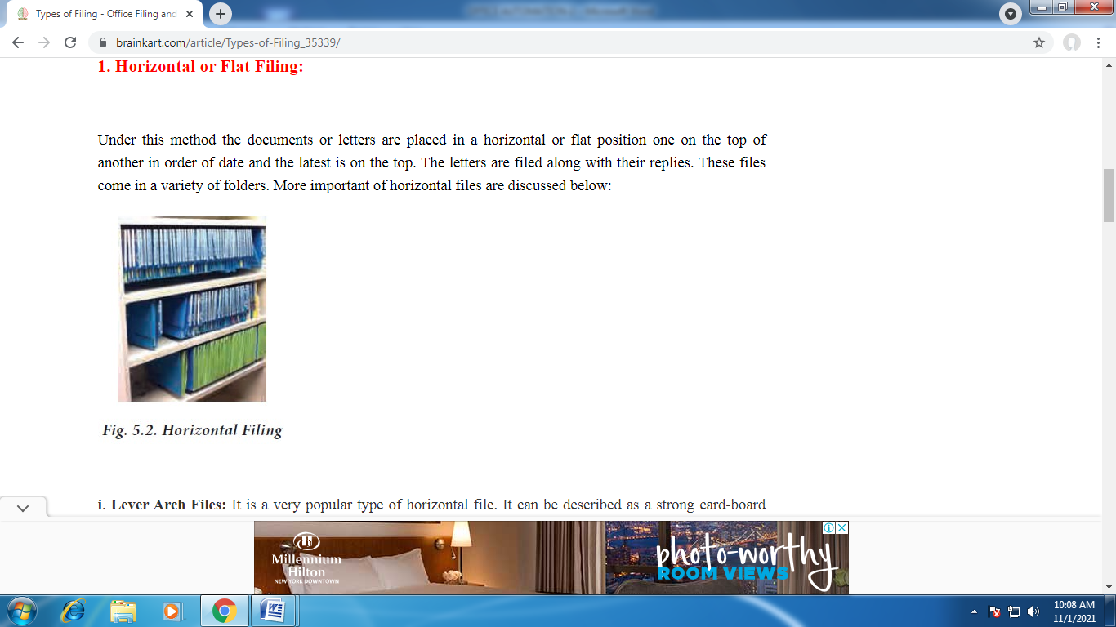
- LEVER ARCH FILES:
It is a very popular type of horizontal file. It can be described as a strong card-board folder which contains strong metal arches which can be opened with the help of a lever. Records to be filed are punched with two holes with the help of the punching machine either at the top or on the left hand side of the forms, and are then files on the metal uprights, after the arch has been opened by the lever. The arch lever file facilitates alphabetical division which is done by inserting thick cards at suitable places. The great advantage of this file is that papers can be inserted or taken out with great ease without disturbing the order of other papers in the file. The file also offers the advantage of proper preservation of papers free from mutilation and dust, if the files are stored properly in the almarahs.

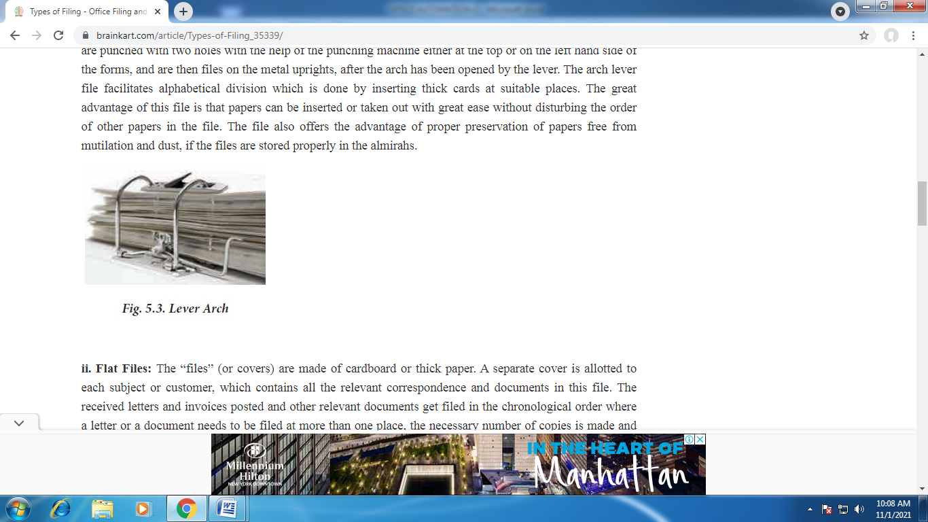
- FLAT FILES:
The “files” (or covers) are made of cardboard or thick paper. A separate cover is allotted to each subject or customer, which contains all the relevant correspondence and documents in this file. The received letters and invoices posted and other relevant documents get filed in the chronological order where a letter or a document needs to be filed at more than one place, the necessary number of copies is made and filed in each relevant file. The flat file has metal hinges which are inserted into the holes punched by the punching machine.

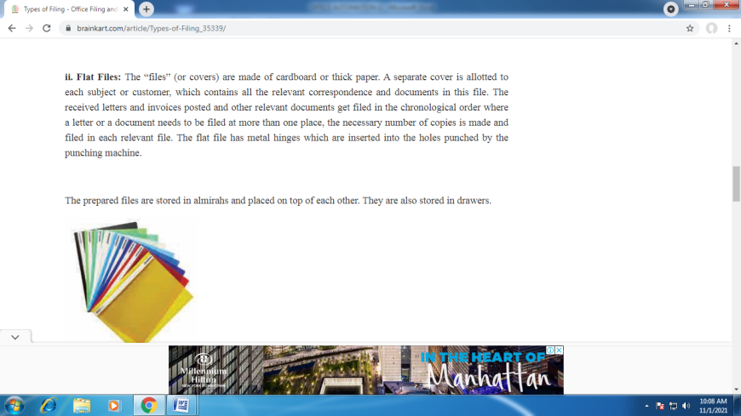
The prepared files are stored in almirahs and placed on top of each other. They are also stored in drawers.

ADVANTAGES OF HORIZONTAL FILING:
1. It is a simple method to operate.
2. It is a cheap method to install.
3. The papers are kept in order in which they have been filed.
4. Speedy reference can be made to papers without removing them.
5. The contents are kept clear and dust free, especially where good covers and almirahs are used.

DRAWBACKS OF HORIZONTAL FILING:
1. Papers cannot be taken out without dislocating other papers because the latest document is on top where a flat file is used.
2. Where a file has become bulky, location of papers become very difficult.
3. It is suitable for offices where transactions are not many.
4. This method does not allow for expansion behind a certain point.
5. It requires an index to find out the concerned file.

2. VERTICAL FILING:
This method of filing can be said to be the most modern. It is so named because the contents are kept in an upright or standing position. This method of filing is the result of the growing needs of business organization. The greatest drawback of the horizontal filing is the time consumed in locating a paper or document. As the business expands, the bulk of papers increases and location of a paper becomes difficult and time consuming activity, vertical filing eliminates this drawback of horizontal filing. Hence it has become a very popular method of filing in large offices where number of subjects is large.
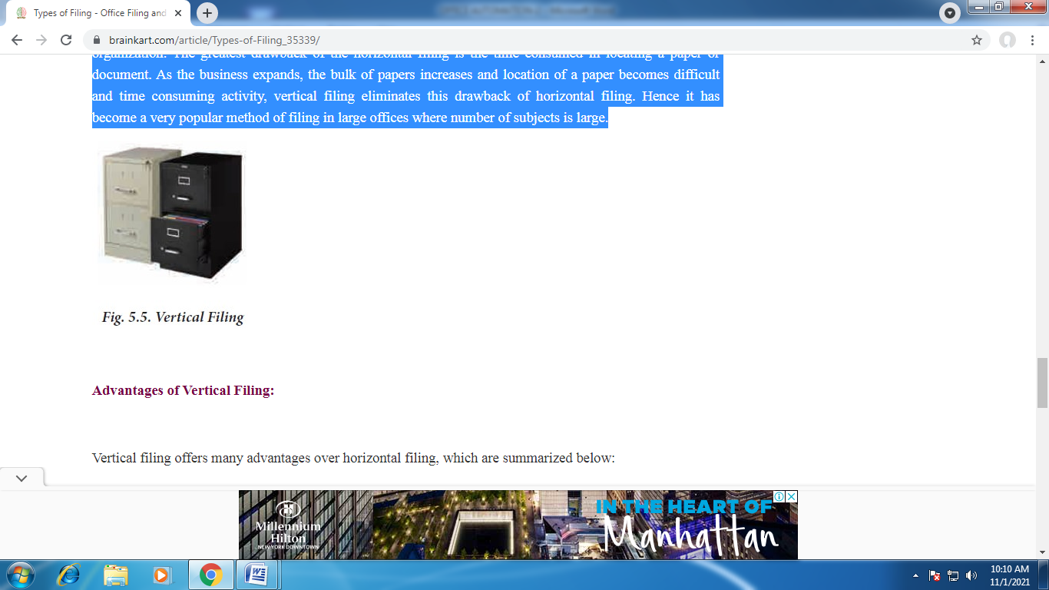

ADVANTAGES OF VERTICAL FILING:
Vertical filing offers many advantages over horizontal filing, which are summarized below:
1. Economical: Vertical filing is more economical on account of two reasons.
• The folders are cheap, and
• Many folders can be accommodated by a single filing cabinet.
Hence there is saving in terms of money as well as space.
2. Ready Reference: Any paper can be traced without wasting time. This is possible because there is a separate folder for each customer or subject and its contents are easily known due to description given on the tab or projected part of the back sheet. Besides, any paper can be inserted and taken out with great ease in a short time.
3. Elasticity: Filing cabinets provide ample scope for expansion of filing facility. A single drawer can accommodate a large number of folders. As the number of folders increases the same drawer can be accommodate more folders upto some extent.
4. Safety and Security: Greater safety is another feature of this method of filing. Papers do not get torn or gather dust since they are well- protected by manilafolders kept safety in drawers, which can also be locked to provide security to confidential documents.
5. Universal Application: Vertical filing has proved useful in preserving all types of papers, documents and memorandum. Orders, invoices, letters, quotations, tenders, government circulars, etc., can be filed with great ease and preserved without difficulty.
6. Adaptability: Vertical filing can be easily adapted to all types of classification. The folders can be arranged alphabetically, numerically, geographically, subject-wise or on some other basis according to the needs of an individual office
CLASSIFICATION OF FILES:
There are five methods of classification. They are:
1. Alphabetical Classification
2. Numerical Classification
3. Geographical Classification
4. Subject Classification and
5. Chronological Classification.

1. ALPHABETICAL CLASSIFICATION:
Alphabetical classification is based on the occurrence of the letters in the alphabet as it is done for the dictionary.
Telephone directory is another example. If several names occur having the first letter, the arrangement takes into account the subsequent letters also, for example:
A, AB, AC ----------- etc
B, Bb, BC ------------- etc.
Under the alphabetical classification, the filing of papers and documents is either by the names of the correspondents or the subjects. In a large office, it would be proper if 26 letters of the English alphabet are divided into small equal parts considering the letters which are bound to have more names. This method of classification can be used in correspondence filing, contracts, orders and staff records.
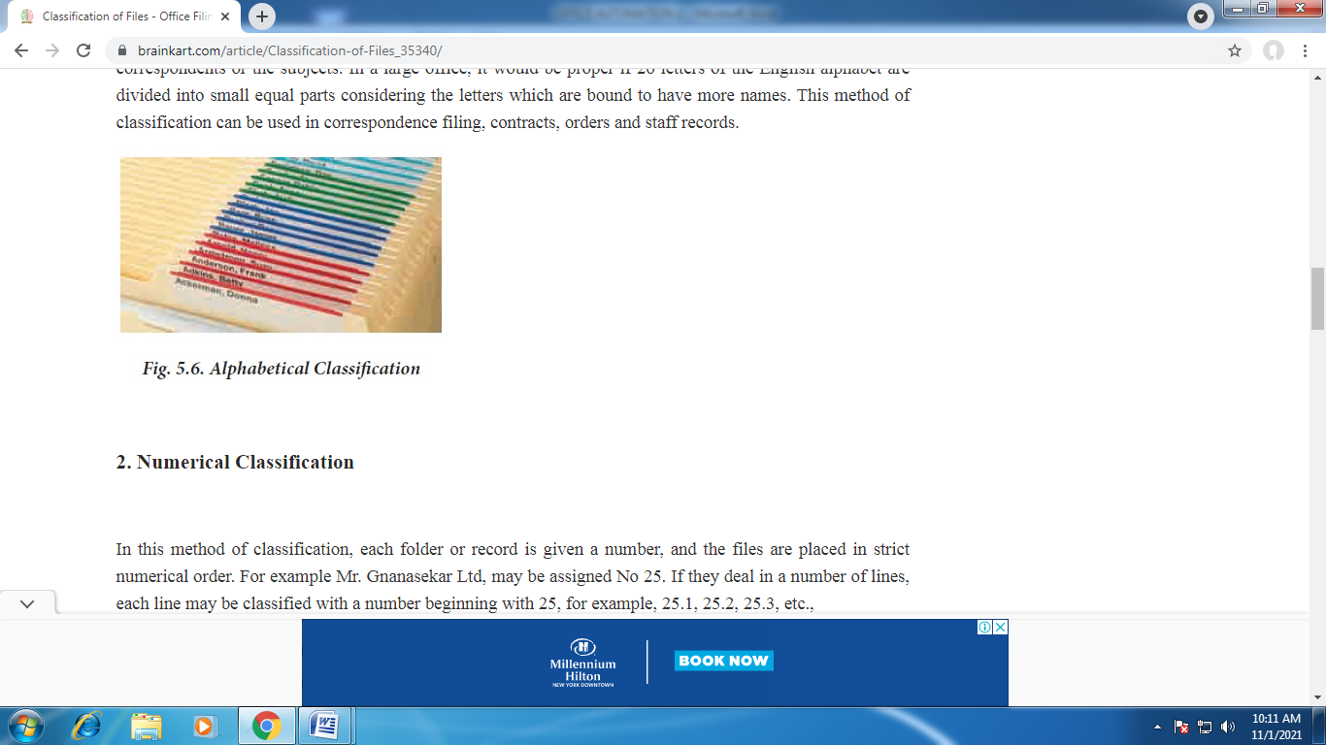

2. NUMERICAL CLASSIFICATION
In this method of classification, each folder or record is given a number, and the files are placed in strict numerical order. For example Mr.Gnanasekar Ltd, may be assigned No 25. If they deal in a number of lines, each line may be classified with a number beginning with 25, for example, 25.1, 25.2, 25.3, etc.,

The system of numerical classification is generally recommended for filing of orders, sales, invoices, contracts, (where numbered) and committee minutes.
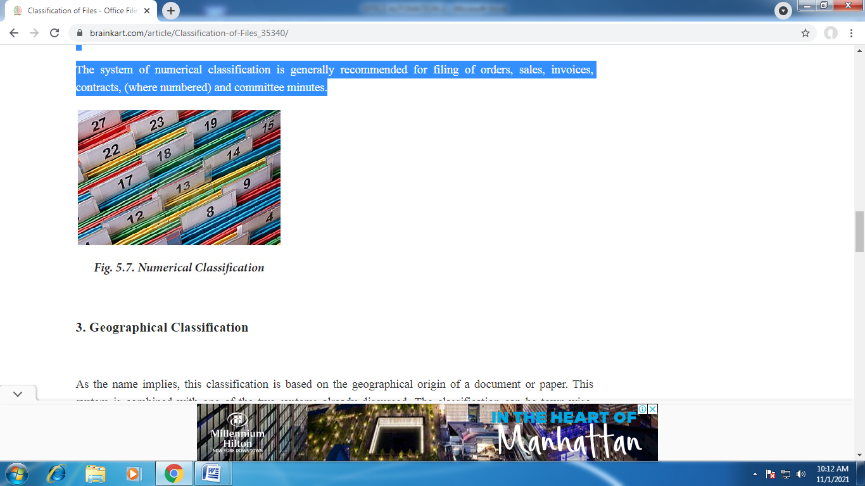

3. GEOGRAPHICAL CLASSIFICATION
As the name implies, this classification is based on the geographical origin of a document or paper. This system is combined with one of the two systems already discussed. The classification can be town-wise, district-wise, state wise, country-wise and continent-wise.
The steps in geographical classification are outlined as follows:
(i). First of all geographical limits are set and areas are defined which will make one unit, for example, in export-import trade
(ii). Next step will be to arrange these countries in their alphabetical order, for example, Algeria, Bolivia, Canada, France, Great Britain, USA and USSR, etc.,
(iii). Within each sub-division classification of different parties may be arranged alphabetically or numerically. Such method of classification is very useful for customers’ orders in a given area and for filing of correspondence according to town.

4. SUBJECT CLASSIFICATION:
It is a method of classification in which all documents relating to a subject are brought together in one file, even though they may have come from different sources and from many different people. Following steps are taken to install subject classification
1. Defining Subject
2. Sub-dividing subjects into smaller fractions
3. Assigning numbers or arranging subjects in alphabetical order, including sub-subjects, and
4. Miscellaneous folders are made for subjects which have not been classified.

Example:
Main Subjects Classified:
Purchases
Sales

5. CHRONOLOGICAL CLASSIFICATION
Under this method various records are identified and arranged in strict date order and sometimes even according to the time of the day. It is a useful method for filing invoices and other vouchers associated with accounts.
This system may be useful if used along with some other system. The records may be arranged alphabetically first and then can be arranged date-wise within each folder. So this system cannot be used independently.
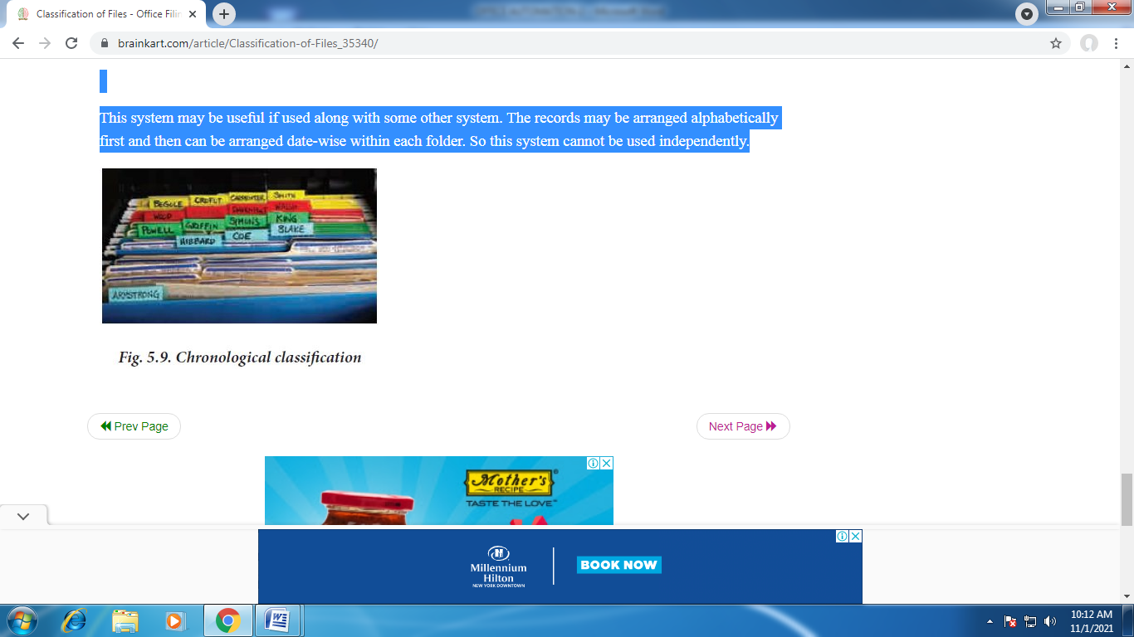

Drafting of Notices, Circulars, Minutes and Resolutions

NOTICE:
The persons entitled to attend a meeting must be informed of the time, place, date and business of the meeting in proper time.
The communication informing the persons entitled to attend the meeting about time, place, date and business of the meeting is called the ‘notice’.
To make the meeting valid, the notice must be served by the right person by the right means to all the persons entitled to attend the meeting. Usually, the notice is drafted and issued by the Secretary under the instruction of the Director of the company. A notice, in order to be valid, must be signed by the proper authority.
The requisites of the meeting can be classified into the following classes:
1. The notice must specify the exact date, time and place of the meeting.
2. The notice must state the nature of business to be transacted at the meeting. A complete agenda is appended to the notice.
3. The notice should be served to all members entitled to attend the meeting.
4. The notice must be clear and unconditional.
5. Proper length of notice must be given in accordance with the rules of the organisation.

CIRCULARS

How a Circular is to be Drafted:
Circular letters are used to communicate the same message to a large number of customers and suppliers. If they are written in an attractive style and in an interesting manner it will be effective for business communication.
When a business-man wants to give publicity to a cause or a campaign they go for circular letters. Through such letters the readers are provided with facts and figures about the firm. The circular letters aim to create the interest in the contents and thereby win the confidence of the readers.
Circular letters are normally used when opening of a new branch, change of premises, introduce a new article, reduction of sales, admission, retirement and death of a partner and change in the constitution of the firm.
While drafting a circular the following points should be kept in mind:
1. The circular letter must be drafted carefully.
2. They must be informative.
3. They must not be ambiguous.
4. The circulars must be courteous in tone and pleasing in form.
5. While drafting a circular letter the purpose of the same should be kept in mind.
6. The circular letter must be concise.
Purposes:
The circular letters are issued for many purposes.
Generally, a circular letter conveys the following types of information:
1. Establishment or transfer of a business.
2. Opening of a new branch.
3. Change of premises.
4. Taking over a business or closing down a business.
5. Dissolution or amalgamation of business.
6. Appointment, discharge or retirement of an important employee.
7. Admission or death of a partner.
8. Issue of bonus shares.
9. Offer of right shares to shareholders.

DRAFTING OF REPORTS:
A report is an organised statement of facts on a particular subject prepared by the writer after proper investigation and enquiry, with or without recommendations. A report may be written by an individual or a Committee or Board of Enquiry.
Types of Reports:
Reports may be of two kinds: Ordinary and Special.
Ordinary reports:
Ordinary reports are made and presented at stated intervals in the usual routine of business. Generally, they contain n mere statement of facts without any opinion or recommendation and merely seek to convey some information on some matter, e.g., Report of Directors to the Annual General Meeting. The facts are stated usually chronologically or subject-wise.
A special report:
A special report is prepared by the individual or by a committee and presented to the superior body requiring it. It contains the recommendations of the writer or writers supported by the facts upon which recommendations are based.
Reports may be also Formal and Informal. A formal report is made according to the requirements of an office or company. It usually follows a prescribed form and established procedure.
An informal report, on the other hand, is one which does not follow any prescribed form or procedure. It is usually written in the form of a personal letter, without any formal procedure involved in it.
Formal reports of a company are of two types—Statutory Reports and Non-statutory Reports.
Statutory reports are those reports which have to be prepared and submitted according to a procedure prescribed by law. Statutory reports include Directors’ Report to the Annual General Meeting, Annual Returns, Auditors’ Report, Reports of the Secretary etc.
Non-statutory reports are those reports which are not required under the provisions of any law but are prepared to help the directors to arrive at right decisions for efficient running of the business. These reports are prepared by the secretary or by the directors themselves to submit to shareholders, employers or committees.
Reports of proceedings in a Court of Law, Reports of proceedings of the Parliament, Newspaper reports of public meetings enjoy ‘qualified privilege’, i.e., they are privileged provided the reports are fair and accurate.

Preparation of Reports:
Every report should be prepared in such a way that the reader can easily understand the points. The main parts of a report are the heading or title, date, address, the body, salutation, complementary close and signature. The body of the report should be divided into paragraphs, each dealing with a particular subject. The report is usually written in a personal form and in the first person.
The following form and arrangement are maintained in every report:
1. The Heading or Title:
Every report should contain the heading or title. It is written on the title page or cover page.
2. Address:
The name of the person or superior body to whom the report has to be submitted.
3. Contents:
It is a list of chapters contained in a report. The title of each topic is given. It may also contain a list of enclosures.
4. Body of the Report:
It is the main part of the report.
The body of report should be divided into the following parts:
1. Introduction:
It is made up of the terms of reference and the subject of study. Here the writer analyses the problem facing him in the light of the terms of reference.

2. Findings:
In this part the writer presents the facts and data collected by him and adds his comments or opinions.
3. Conclusion and Recommendation:
In this concluding part of the report the writer arrives at certain conclusions on the basis of the data and facts. He then presents some definite suggestions of his own. When the report is prepared by a committee for presentation to a general body for adoption, recommendations should be made in the form of ‘motions’ or ‘resolutions’.
4. Reference and Bibliography:
A report should contain a list of references and bibliography just after the index so that the reader can understand the sources of information.
5. Index:
In case the report is lengthy an index of the contents of the reports is added after the bibliography.
6. Summary:
When the report is very lengthy a summary of the findings and recommendations of the report is appended.
7. Signature:
Every report must be dated and signed by the person or committee submitting it. If the report is unanimous, the signature of the chairman will do. If the report is not unanimous a separate minority report with the notes of dissent has to be submitted with the majority report.
GUIDELINES FOR REPORT WRITING:
No hard and fast rules can be laid down regarding report writing. Any language and style may be adopted in writing reports so long as they serve the main purpose for which the report is being written.
However, some general principles can be laid down which will help the report writer:
1. The language should be simple and clear. Short and simple sentences should be used as far as possible.

2. Negative statements should be avoided as far as possible.
3. The report should be better written in the narrative form.
4. The data used in support of conclusion must be accurate and reliable.
5. No such technical term should be used which is not understood by the people for whom the report is written.
6. The report should be as brief as possible. Repetition should be avoided.

MINUTES AND RESOLUTIONS:
Minutes are the official records of the proceedings of a meeting. Minutes that are approved and signed is treated as an evidence in the court of law. For joint stock companies, it is compulsory to maintain the proceedings of every general meeting, board meeting and of committees. The main object of writing minutes is to record what was formally resolved or decided upon.
The writing-up of the minutes is the responsibility of the secretary. During the meeting he should take brief notes of the proceedings. Each important point should be carefully noted. After the meeting the minutes should be written-up in the minute book from the notes. All pages of the minute’s book should be numbered consecutively and, after confirmation, each page should be signed by the chairman.
The minutes should record the business in the following order:

1. The nature of each meeting should be mentioned.
2. The date, time and place at which the meeting is held must be mentioned.
3. The names of the presiding officer, members in attendance and the secretary should be mentioned.
4. The minutes of the last meeting be read, confirmed and signed by the chairman.
5. Each item in the minutes be numbered with a brief heading.
6. The minutes should be impersonal. Reported speech and passive voice are used in writing minutes.
7. Names of absentees and apologies for absences received.
8. Resolutions adopted with names of movers and seconders, manner of voting and results.
9. Usually the rough draft of the minutes is shown to the chairperson and, with his approval, the final draft is prepared.

PRESS NOTES
Definition :
Press notes are those devices of communication, by which a Government policy or an important announcement is issued for the information of the public. In its nature, a press note is important as compared with the handout in all implicit and explicit aspects. It is usually drafted and composed in formal language from the textual point of view, no deviation is permissible. It also designed to communicate and transmit information in strict sense of the word, with no deviation allowable.

Basic points :
From the study and examination of the definition and nature of the press note, we can deduce the basic points as enumerated below:
1. Press notes are issued by the Government for the information of the general public.
2. Press note contains information in unambiguous and categorical terms.
3. Press notes are invariably linked with the basic policy or stand of the Government on some specific issues.
4. Press notes are specially attuned to accuracy of presentation, whereby a sort of credibility iscreated.
5. Press notes are the effective tools of bridging the communication gap, by resorting to both the outward and the inward public relation.
6. Press notes normally carry the idea of firm stand on the part of the Government.
7. Press notes are usually reproduced in the newspaper and other mass media in the similar order and manner, as they are received.
8. Press notes are closely related to the announcements of Government’s basic policy as such the newspapers cannot change, reduce or alter their contents in any manner.
9. Press notes as being firm stand and Governments basic policy, is not liable to frequent alteration. As such these are usually and decidedly the last work, which may, however, be revised if genuinely required.
10. The frequency of the press note is not the same as with the handouts. It is undertaken only to highlight the stand and the viewpoint of the Government on some significantly national event or issue and when needed.
ELEMENTS:
Any information deliberately sent to a reporter or media source is considered a press release. This information is released by the act of being sent to the media. Public relations professionals often follow a standard professional format for press releases. Additional communication methods that journalists employ include pitch letters and media advisories. Generally, a press release body consists of four to five paragraphs with a word limit ranging from 400 to 500.^{[3]} Press release length can range from 300 to 800 words.^{[4]}
Common structural elements include:
- Letterhead or Logo
- Media Contact Information – name, phone number, email address, mailing address, or other contact information for the public relation (PR) or other media relations contact person.
- Headline – used to grab the attention of journalists and briefly summarize the news in one to six words.
- Dek – a sub-headline that describes the headline in more detail.
- Dateline – contains the release date and usually the originating city of the press release. If the date listed is after the date that the information was actually sent to the media, then the sender is requesting a news embargo.
- Introduction – first paragraph in a press release, that generally gives basic answers to the questions of who, what, when, where and why.
- Body – further explanation, statistics, background, or other details relevant to the news.
- Boilerplate – generally a short "about" section, providing independent background on the issuing company, organization, or individual.
- Close – in North America, traditionally the symbol "-30-" appears after the boilerplate or body and before the media contact information, indicating to media that the release has ended. A more modern equivalent has been the "###" symbol. In other countries, other means of indicating the end of the release may be used, such as the text "ends".
As the Internet has assumed growing prominence in the 24-hour news cycle, press release writing styles have evolved. Editors of online newsletters, for instance, often lack the staff to convert traditional press release prose into the print-ready copy.

RECORD
Records are anything containing information which is made, produced, executed, or received in connection with the transactions and official activities of the University or executed in the conduct of University business, including research, teaching, service, and administration. Examples include documents, books, paper, electronic records, photographs, videos, sound recordings, databases, and other data compilations that are used for multiple purposes, or other material, regardless of physical form or characteristics.
Records can be divided into two categories: 1) Official, and 2) Transitory/Convenience.
- a. "Official records" are:
  - (1) records having the legally recognized and judicially enforceable quality of establishing some fact, policy, or institutional position or decision.
  - (2) the single official copy of a document maintained on file by an administrative unit of the University which is usually, but not always, the original.
  - (3) subject to the records retention requirements included in the Records Management Program and Retention Schedule.

b. "Transitory/convenience records" are:
  - (1) duplicate copies of official records.
  - (2) extra copies of documents or records created or preserved for convenient access and/or for reference, including computer backups and duplicate computer files. (See University of Iowa IT Backup and Recovery Policy for specifics on electronic record backup.
  - (3) miscellaneous papers or correspondence without official significance such as post-it notes, letters of transmittal, or route slips.
  - (4) versions or drafts of reports, memos, word processing files, letters, messages, or communication (electronic or otherwise) that are used to develop a final official document.
  - (5) records that do not carry a requirement for retention and should be destroyed when they cease to be useful (using secure destruction methods if they contain confidential information).

INVENTORY
Inventory is the accounting of items, component parts and raw materials a company uses in production, or sells. As a business leader, you practice inventory management in order to ensure that you have enough stock on-hand and to identify when there’s a shortage.
The verb “inventory” refers to the act of counting or listing items. As an accounting term, inventory refers to all stock in the various production stages and is a current asset. By keeping stock, both retailers and manufacturers can continue to sell or build items. Inventory is a major asset for most companies. However, while inventory is an asset on the balance sheet, too much inventory can become a practical liability.
Inventory Examples
Real-world examples can make inventory models easier to understand. The following examples demonstrate how the different types of inventory work in retail and manufacturing businesses.
Raw Materials/Components:
A company that makes T-shirts has components that include fabric, thread, dyes and print designs.
Finished Goods:
A jewelry manufacturer makes charm necklaces. Staff attaches a necklace to a preprinted card and slips it into cellophane envelopes to create a finished good ready for sale. The cost of goods (COGS) of the finished good includes the packaging it comes in as well as the labor to make the item.
Work In Progress:
A cell phone consists of a case, a printed circuit board, and components. The process of assembling the pieces at a dedicated workstation is WIP.
MRO Goods:
Maintenance, repair and operating supplies for a condominium community include copy paper, folders, printer toner, gloves, glass cleaner and brooms for sweeping up the grounds.

Packing Materials:
At a seed company, the primary packing material is the sealed bag that contains, for example, flax seeds. Placing the flax seed bags into a box for transportation and storage is the secondary packing. Tertiary packing is the shrink wrap required to ship pallets of product cases.
Safety Stock:
A veterinarian in an isolated community stocks up on disinfectant and dog and cat treats in case the highway floods during spring thaw, delaying delivery trucks. The veterinarian stocks up on these items to meet customer demand.
Anticipated/Smoothing Inventory:
An event planner buys discounted spools of ribbon and floral tablecloths in anticipation of the June wedding season.
Decoupled Inventory:
In a bakery, the decorators keep a store of sugar roses with which to adorn wedding cakes–so even when the ornament team’s supply of frosting mix is late, the decorators can keep working. The flowers are part of the cake’s design. If the baker ran out of them, they couldn’t deliver a finished cake.
Cycle Inventory:
As a restaurant uses its last 500 paper napkins, the new refill order arrives. The napkins fit easily in the dedicated storage space.
Service Inventory:
A café is open for 12 hours per day, with 10 tables at which diners spend an average of one hour eating a meal. Its service inventory, therefore, is 120 meals per day.
Theoretical Inventory Cost:
A restaurant aims to spend 30% of its budget on food but discovers the actual spend is 34%. The “theoretical inventory” is the 4% of food that was lost or wasted.
Book Inventory:
The theoretical inventory of stock in the inventory record or system, which may differ from the actual inventory when you perform a count.

Transit Inventory:
An art store orders and pays for 40 tins of a popular pencil set. The tins are en route from the supplier and, therefore, in transit.
Excess Inventory:
A shampoo company produces 50,000 special shampoo bottles that are branded for the summer Olympics, but it only sells 45,000 and the Olympics are over—no one wants to buy them, so they’re forced to discount or discard them.

INVENTORY ASSISTANT SKILLS AND QUALIFICATIONS
Inventory assistants must manage a number of different responsibilities while on the job. Because their tasks are so varied, employers look for candidates who possess several different abilities, including the following:
- Detail oriented – inventory assistants are in charge of managing large amounts of stock, which requires a detail-oriented personality
- Physical stamina – inventory assistants are frequently required to lift heavy boxes, stoop, kneel, squat, and perform other physical tasks
- Mathematics skills – inventory assistants have to be good with numbers and figures because they compare prices, count stock, and do other calculations on a regular basis
- Computer literacy – because inventory assistants must work with spreadsheets and other computer software, some computer skills are a must
- Manual dexterity – inventory assistants must work with their hands and their bodies, which requires good manual control. Clumsy people are not ideally suited for this job
- Customer service – inventory assistants are frequently required to speak with customers, vendors, and other employees, which requires excellent customer service skills

MAINTAINING INVENTORY RECORDS
- Adjusting Stock Levels
- Recording the Receipt of Goods
- Transferring Stock Between Inventory Locations
- Ordering Stock
- Checking Stock Levels
- Inspecting Stock History

Adjusting Stock Levels
The Stock Levels tab is important for managing stock quantities. It lists all the product variations and the possible stockpoints.
In the Adjustment field, enter the correction that is required. If Inventory has fewer items on record than are actually on hand, enter a positive number to make the right correction. If Inventory has more items on record than are available for sale, enter a negative number to correct the Inventory record. When entering existing stock levels when setting up Inventory, this means we enter the number of items on hand.
There is a Reason field with options to select. The options are customised in Administration at Setup > Inventory > Transaction Reasons. Examples could include Initial Stock and Write-offs. Depending on how the transaction reason has been specified, you may also be required to enter a comment further explaining the stock adjustment. For example, if Write-offs requires a comment when selected, "shop soiled" might be entered to explain the correction.

Recording the Receipt of Goods
When shipments arrive from a supplier, enter the shipment quantities into Inventory.
In the Stock Receipt window, select the Supplier of the shipment from the list of options. Enter the shipment Reference from the consignment slip, correct the Unit Cost if necessary, and enter the Qty to Receipt. Make sure you enter the number of product items, not the number of shipping units. If three packets of t-shirts arrive, and each packet holds five t-shirts, the consignment slip may specify 3 packets, but Inventory needs to be told about 15 t-shirts being entered into the system. In this case, 15 would be the correct number to enter.

Transferring Stock Between Inventory Locations
Transferring stock between inventory locations is necessary when moving stock from storage to sale locations, or when one sale location requires an item in stock at another sale location. Select a product variation at the location you are moving products from,

Ordering Stock
When your inventory reports inform you that stock levels have reached or fallen below the Reorder point, find the product and in the Stock Levels t
In the Stock Order window, enter the same details as you are entering into the purchase order to the supplier. Select the Supplier you are using from the list, enter the order Reference number or code, correct the Unit Cost if this has changed, and specify the Quantity being ordered.

Checking Stock Levels
To check stock levels, open the Products window in Administration by opening Setup > Sales > Products. Open the Stock Levels tab.

Inspecting Stock History
To see an audit trail of Inventory transactions for any product, open the Products window in Administration by opening Setup > Sales > Products. Open the Stock History tab. The Stock History tab will display a list of all the adjustments, corrections, orders, and sales for each product variation and location.
MAINTAINANCE OF HUMAN RESOURCES
, Maintenance function of human resource management is concerned with protecting and promoting the physical and mental health of employees. In order to achieve these objective several types of fringe-benefits such as housing, medical and, educational facilities, conveyance facilities etc. are provided to the employees.
Social security measures like provident fund, pension, gratuity, maternity benefits, group insurance etc. are also arranged. Health, safety and welfare measures are designed to preserve the human resources of the organisation.

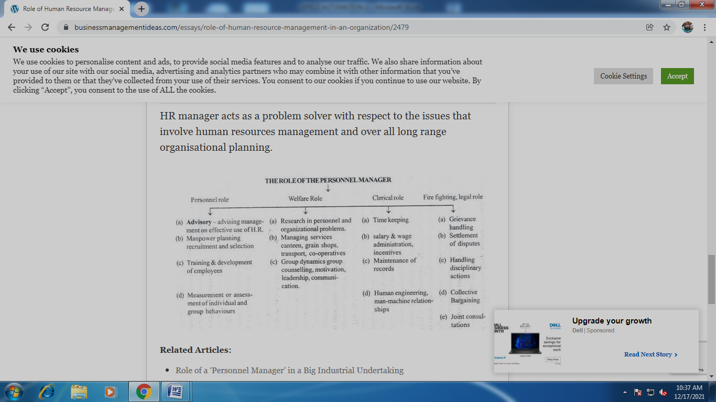

Maintenance of Employee’s Health:
This is an important function of personnel management. For this task, certain provisions are given in ‘Factory Act’, which must be strictly followed. In addition, when a new worker is appointed, he should first be medically examined to ensure that he is physically fit to perform duties. If a worker on a medical examination is not found fit, he should not be given appointment, otherwise it will cause increase in labour turnover and other troubles.

Maintenance of Employee’s Safety:
This is also an important function of personnel management. For this, some provisions are given in ‘Factory Act’; those are required to be enforced by the employer. Safety is obtained by proper inspection of plant and machinery, work place, fire protection, first-aid premises, and arranging safety education programmes.
Everyone working in the factory should know the causes of accidents and how to prevent them. If there are no accidents, large number of workers will be willing to compete for the job. Accidents discourage the workers and reduce output.

Labour Welfare:
Labour welfare is the voluntary efforts by the employers to provide best conditions of employment in their own industries.
The object of introducing labour welfare scheme is to secure an improved standard of living for the workers, which results in the increase in their productive efficiency.
Labour (Personnel) welfare schemes are aimed at:
1. Making the employees healthier, sound thinking
2. To motivate people to carry out production in a better way,
3. To improve and maintain employees morale and loyalty.
4. To keep workforce in competition with other organisations,
5. To maintain better employee-employer relations.
6. To meet the social, recreational and cultural needs of the employees.
7. To reduce the labour turn-over, absenteeism.
Welfare Measures:
Welfare measures can be categorised as:
1. Economic Welfare Measures:
  - Health services and first aid,
  - Paid holidays, reduced hours of work,
  - Profit sharing,
  - Pension scheme,
  - Insurance scheme, including group insurance,
  - Subsidised lunch, water, electricity, and
  - Loans on reduced rate of interest.
2. Facilitate Welfare Measures:
  - Housing,
  - Transport,
  - Canteen and lunch facility,
  - Company stores for cheaper shopping,
  - Sale of company products on discount to employees,
  - Educational facilities,
  - Rest rooms,
  - (h) Safety measures, and
  - Measures to reduce fatigue.
3. Recreational Measures:
  - Games and Sports.
  - Recreational clubs.
  - Cultural programmes.
  - Social get-togethers.

MAINTAINANCE OF HUMAN RELATIONS
Labourers in India usually belong to poor and illiterate class. The wages given to them are not sufficient to maintain them and their families properly. Their standard of living is low and they do not possess any reserves, which can be utilised during sickness and unemployment.
Their wages are not enough even to meet their daily necessities. Their diet is poor and they have to live in small houses situated in unhealthy surroundings. They cannot afford modern costly medical aid.
Thus the ‘Human-relations’ is the key to maximum productivity for both the employer and employee. The maximum prosperity for each employee does not mean only higher wages but also the development to the state of his maximum prosperity to the employer and with maximum benefits to each employee.

Factors Responsible for Human Relations:
We can summarise the important factors, which are responsible for affecting the human relations into the following categories:
1. Physiological needs.
2. Safety needs.
3. Social needs.
4. Self-realisation needs.

1. Physiological needs:
These are the necessities of food, cloth and shelter. These needs must be fulfilled so as to keep worker worriless. Workers also want a guarantee that these needs will also be met in future.
2. Safety needs:
An employee also wants security for job and protection against danger and threat.
3. Social needs:
Main social desires of a man are reputation, confidence, appreciation, independence and strength. These needs can be recognised by providing the participation of employees in the organisation.
4. Self-realisation needs:
Man always desires that he should be put to such job for which he is fit. A person will not remain happy on the post which is lower than that for which he is suitable.

Suggestion for the Improvement in Human Relations:
It is very necessary for the management to develop a climate which will motivate the employees to do more and will help to achieve the satisfaction.

To improve the human relations, following suggestions are being given:
1. Proper Wages:
A worker should get sufficient wages, so as to fulfil his minimum needs. For better human relations, decent wages should be paid to the worker. This will then result in increased production and more prosperity and will thus benefit both the employer and employee.
2. Special Inducement:
Fair wages satisfy only physiological needs of the employee, but to get the maximum output some incentives, in the form of promotion, bonuses etc. are necessary.
3. Mutual Trusteeship:
Mutual trust and social responsibility on the part of both labour and management reduces the conflicts and it will help in the increase of sense of cooperation.
4. Open Communication:
Exchange of views, information and feelings are very essential as a means of promoting communication among various sections. These help in understanding each other and making decisions. For this purpose Works Committee, Joint Management councils are framed having a suitable representation of labour and management.
5. Suggestion Programme:
By this scheme, employee takes live interest in the affairs of the company, specially in the matter of production. In the absence of such programme, employee generally criticises the management as a whole or the departmental head and the sectional supervisors.
In the performance of a task, the employees may have bright ideas about the way in which the things would or could be done. If workers are given the opportunities to put these ideas forward, a valuable idea may be received. Sometimes the suggestions are of immense value. The employee giving valuable suggestion may be awarded to encourage the persons to take more interest in the scheme.
6. Human Dignity:
It is the desire of every man that he should be treated with respect and dignity. Human-dignity is the moral basis for human relations. Each individual should therefore be recognised as a separate personality. Human-dignity cannot be wholly awarded by the management. Worker should also try himself to attend it by means of his personal growth.

Advantages of Labour Welfare:
(i) Make the employees healthier, more forward looking
(ii) Contributes for motivation and improving moral and loyalty
(iii) Interest for work is created
(iv) Helps in maintaining good industrial relations
(v) Satisfy the social, cultural and recreational needs of the employees
(vi) Reduces labour turn-over and absenteeism
(vii) Reduces relations amongst employees.

Maintenance of Personnel Records:
It is the duty of the personnel manager to evaluate periodically as to how effectively the human resources are being utilised. For exercising control over human resources, it is necessary to have personnel records, reports, research and audit. Personnel records include the documents and files relating to the human resources of the organisation.
The record contains information on manpower plans, recruitment, selection, training, compensation, appraisal, job changes. Job applications, test scores, results of medical examination, labour turnover and absenteeism data, morale surveys, wage and salary data are some of the examples of personnel records.
These records are maintained to serve the following purpose:
(i) To provide information required for taking decisions on personnel matters.
(ii) To provide an evidence of what has taken place in the organisation.
(iii) To provide a basis for evaluating, formulating and modifying the personnel policies and programmes.
(iv) To meet legal requirements under various labour laws.

Conducting Personnel Audit:
Personnel audit implies critical examination and evaluation of policies, programmes and procedures in the area of human resource management. It should be conducted periodically to measure the effectiveness of personnel management and to determine the steps required for more effective use of human resources.
The aim of personnel audit is to determine whether the personnel policies and practices are consistent with oganisational objectives. It also aims to find out as to how effectively the personnel policies and programmes have been implemented.
Personnel audit is actual evaluation of personnel policies, programmes and results. After the completion of audit the personnel auditor submits a written report containing actual data and recommendations.

Financial Record Maintenance

Financial records
The Act requires records to be kept of the association's finances. Taxation and industrial legislation also require financial records to be kept. Access to accurate and up-to-date financial information also ensures that the association and its services remain viable.
The requirements of the Act are:
- associations must keep sufficient accounting (or financial) records so that the financial transactions , financial position and performance of the association are correctly recorded;
- these records need to be kept in a way that will allow true and fair accounts (or financial statements) to be prepared, and so that these accounts can be conveniently audited if required; and
- the financial records are required to be kept for at least seven years.
Depending on the association's annual revenue there may be additional accounting requirements to be met. These requirements are discussed in detail in Accounts and Auditing.

Annual report
Many associations compile an annual report that summarises the main achievements and highlights of the past 12 months. There is no set format for an annual report, but it is usually submitted to members at the AGM and includes:
- Chairperson's report.
- Staff report.
- Activity report.
- Annual statistics.
- Annual financial report.
- Interest stories, highlights and low points.
- List of staff, management and volunteers.

Employment records
- Recruitment records such as job descriptions, selection criteria, related industrial agreements, advertisements, selection processes and outcomes;
- formal records of any meeting or discussion related to issues of employee performance and position review;
- formal documentation of all proceedings related to any grievance;
- records on staff training and professional development; and
- copies of all correspondence and memoranda relating to individual conditions of employment, changes or requests.

Safety records
The following health and safety records should be kept in a separate file for easy access and reference:
- complaints;
- incidents;
- risk management analysis;
- training details;
- safety committee minutes; and
- copies of specific management committee resolutions.

Insurance records
Copies of all insurance policies should be kept in a secure place. Changes to policies should be updated on the files immediately when they are received.
Insurance policies may require an association to keep specific records for the purposes of validating a policy. For example health declarations or assets registers. Associations must notify their insurer as soon as possible after events such as an accident, theft or fire. It is important associations keep copies of all notifications and correspondence to prevent the possibility of any dispute regarding an association's obligations.

Service delivery records
Some associations need to keep service delivery records in order to:
- acknowledge achievements;
- minimise risk of professional negligence;
- facilitate communications and change overs;
- ensure industry or professionally based requirements are met; and
- assist in evaluation and planning.
This may take the form of statistic sheets, case files or employee reports. Funding arrangements may also require certain records to be kept and reported on.

Record of office holders
Associations are required to maintain an up-to-date record of the names and addresses of all current office bearers, committee members and those members who are authorised to use the common seal or act as trustees for the association. The address recorded in the record office holders may be a residential, business or post office box address or an email address.
As is the case with the members’ register, members are entitled to view the record of office holders upon request and make a copy of all or part of the record. They may not remove the record for this purpose. Furthermore the inspecting member must not disclose or use the information unless the purpose is directly connected to the affairs of the association.
Organisations run best when members can easily contact their committee and many groups make committee contact information freely available for this purpose.

Rules of association
Every association must have a set of rules, often known as a ‘constitution’, that govern the way in which an association operates. Changes to these rules may only be made by passing a special resolution at a general meeting. This process is explained in Altering the Rules.
The Act also requires a copy of the rules to be held by Consumer Protection as the 'official' version of the association’s rules. The rules lodged by an association with Consumer Protection (including any amendments) are the only effective rules of the association.
The association must give each new member a copy of the rules in force when their membership starts. The association can comply with this obligation by:
- providing a hard copy of the rules
- emailing an electronic copy of the rules to the member; or
- providing the details for a website where the member can download a copy.
Please note that if the member specifically requests a hard copy of the rules the association must provide the document in this format.

Privacy and confidentiality of records
Associations need to ensure they comply with legal requirements regarding any personal information it holds about clients, employees, members and other individuals. Any personal information collected must be kept private and confidential and individuals have a right to:
- have their privacy rights respected;
- be assured their information will not be passed onto a third person unless it is authorised by law or they have given their consent;
- know what information will be kept and why; and
- be assured that information will only be used for the purpose it was supplied.

Custody and handover of records
The Act requires an association’s rules to include details of who will have custody and responsibility for keeping the records. These responsibilities are typically shared between the members of the management committee, for example the Treasurer may be responsible for custody of the financial records while the Secretary may keep everything else.
If a person ceases to be a member of the management committee through the ending of their term, resignation or death, it is a requirement that any association records they hold be delivered to a current member of the association’s committee as soon as practicable

PUBLIC RELATIONS
Public relations is a strategic communication process companies, individuals, and organisations use to build mutually beneficial relationships with the public.
A public relations specialist drafts a specialised communication plan and uses media and other direct and indirect mediums to create and maintain a positive brand image and a strong relationship with the target audience.
In simple terms, public relations is a strategised process of managing the release and spread of organisation-related information to the public to maintain a favourable reputation of the organisation and its brands. This process focuses on –
- What information should be released,
- How it should be drafted,
- How it should be released, and
- What media should be used to release the information (usually earned or free media is used for the same).

What Is The Objective Of Public Relations?
The main objective of public relations is to maintain a positive reputation of the brand and maintain a strategic relationship with the public, prospective customers, partners, investors, employees and other stakeholders which leads to a positive image of the brand and makes it seem honest, successful, important, and relevant.

Functions Of Public Relations
Public relations is different from advertising. Public relations agencies don’t buy ads, they don’t write stories for reporters, and they don’t focus on attractive paid promotions. The main role of public relations is to promote the brand by using editorial content appearing in magazines, newspapers, news channels, websites, blogs, and TV programs.
Using earned or free media for promotion has its own benefits as information on these mediums aren’t bought. It has a third-party validation and hence isn’t viewed with scepticism by the public.
The functions of public relations managers and public relations agencies include:
- Anticipating, analysing, and interpreting the public opinion and attitudes of the public towards the brand and drafting strategies which use free or earned media to influence them.
- Drafting strategies to support the brand’s every campaign and new move through editorial content.
- Writing and distributing press releases.
- Speechwriting.
- Planning and executing special public outreach and media relations events.
- Writing content for the web (internal and external websites).
- Developing a crisis public relations strategy.
- Handling the social media presence of the brand and responding to public reviews on social media websites.
- Counselling the employees of the organisation with regard to policies, course of action, organisation’s responsibility and their responsibility.
- Handling investor relations.

TYPES OF PUBLIC RELATIONS
According to the functions of the public relations department/agencies, public relations can be divided into 7 types. These are:
- Media Relations: Establishing a good relationship with the media organisations and acting as their content source.
- Investor Relations: Handling investors events, releasing financial reports and regulatory filings, and handling investors, analysts and media queries and complaints.
- Government Relations: Representing the brand to the government with regard to the fulfilment of policies like corporate social responsibility, fair competition, consumer protection, employee protection, etc.
- Community Relations: Handling the social aspect of the brand and establishing a positive reputation in the social niche like environment protection, education, etc.
- Internal Relations: Counselling the employees of the organisation with regard to policies, course of action, organisation’s responsibility and their responsibility. Cooperating with them during special product launches and events.
- Customer Relations: Handling relationships with the target market and lead consumers. Conducting market research to know more about interests, attitudes, and priorities of the customers and crafting strategies to influence the same using earned media.
- Marketing Communications: Supporting marketing efforts relating to product launch, special campaigns, brand awareness, image, and positioning.

Advantages of Public Relations
- Credibility: Public trusts the message coming from a trusted third party more than the advertised content.
- Reach: A good public relations strategy can attract many news outlets, exposing the content to a large audience. Moreover, this medium can help the company utilise certain organic touchpoints that are hard to capitalise on otherwise.
- Cost effectiveness: Public relations are a cost effective technique to reach large audience as compared to paid promotion.
- Better Communication: Public relations help the company to communicate more information to the public than other forms of communication media.

Disadvantages Of Public Relations
- No Direct Control: Unlike paid media, there isn’t a direct control over the content distributed through the earned media. This is the biggest risk of investing in public relations.
- Hard To Measure Success: It is really hard to measure and evaluate the effectiveness of a PR campaign.
- No Guaranteed Results: Publishing of a press release isn’t guaranteed as the brand doesn’t pay for it. The media outlet publishes it only if it feels that it’ll attract its target audience.
- Importance Of Public Relations
- With over 63% of the value of most companies dependent on their public image, public relations has become a very important topic today for numerous reasons
******^^^^*******
“You can run the office without a Boss,
But you can’t run an office without
‘OFFICE SECRETARIES;”.
ALL THE BEST

